School of Digital Technologies and Arts
Department of Computing

COMP60010: Enterprise Cloud and Distributed Web Applications

Assignment Specification

Weighted at 50% of the module mark

Submission Guidelines

All submissions are only electronic and should be submitted via Blackboard. If you have any questions/queries, please contact the tutor.

Submission deadline: Wednesday 30 September 2026 (23:59)

Learning outcomes being assessed by this assignment are:

3. DESIGN, IMPLEMENT AND TEST A WEB APPLICATION BASED ON THE CLOUD AND CLOUD SERVICES
4. DEVELOP, IMPLEMENT AND, TEST A DISTRIBUTED WEB APPLICATION UTILISING AN APPLICATION PROGRAM INTERFACE (API).

Table of Contents
Table of Figures 4
1. Introduction 5
2. Requirements and System Objectives 5
3. Architecture and Design 6
7
4. Microservices and Containerisation 7
5. API Design and Gateway/Load Balancing 10
5.1 API testing in Postman 11
6. Event-Driven Architecture 12
7. Security and Identity 14
8. Resilience, Scalability and Disaster Recovery 16
9. Monitoring and Observability 18
10. Infrastructure as Code with CloudFormation 19
11. Testing and Validation 20
Test Cases 24
Functional and API 24
API Testings 27
API-specific tests 27
Security Testings 29
Integration Testings 31
End–to–end Testings 32
Performance Testings 33
Monitoring and Observability 34
12. Results and Discussion 35
13. Limitations and Future Improvements 35
14. Conclusion 36
References 37
Appendices 38

Table of Figures
lambda 1 50

LB 1 11

managed services 1 38

order service 1 10

product service 1 9

route tables 1 40

subnet 1
swagger 1 42
swagger 2 43
swagger 3 44
swagger 4 45
swagger 5 46
swagger 6 47
swagger 7 48

user service 1 10

VPC 1 40
40

1. Introduction
Demonstrating the development and deployment of a scalable cloud-native retail platform is the aim of SmartRetailX. Continuous modification, fault isolation, and independent scaling can be challenging with traditional monolithic deployments. As a result, SmartRetailX employs a microservice-oriented strategy that divides and deploys business capabilities separately. Instead of a merely theoretical design, the assignment calls for a realistic implementation that includes source code, infrastructure configuration, API implementation, event-driven communication, security measures, testing, monitoring, and deployment evidence.
The implementation was created piecemeal. The setup was set up by manually configuring the initial AWS networking and supporting resources. When necessary, CloudFormation is then utilised for infrastructure-as-code. According to AWS, CloudFormation makes it possible to describe and provision infrastructure as a stack in a predictable and repeatable manner (AWS, 2026a). This enhances reproducibility and offers
Appendices

2. Requirements and System Objectives

Providing an e-commerce backend that can support users, products, and orders is the primary functional goal. In order for an order to initiate downstream processing without tightly connecting every component, the system also requires inventory management and customer notifications. Scalability, resilience, security, observability, and quantifiable performance are examples of non-functional goals.
- separate microservices for managing orders, products, and users.
- containerised deployment with Amazon ECS/Fargate and Docker.
- Role-based permissions and safe API access.
- processing based on events using Amazon EventBridge.
- centralised operational monitoring and application logging.
- load balancing and horizontal scaling.
- Performance validation, end-to-end, integration, and API.

3. Architecture and Design
A distributed microservice model is used in the architecture. OrderService oversees order creation and lifecycle operations, ProductService oversees catalogue information, and UserService oversees user-related operations. NotificationService manages notification events, whilst InventoryService is in charge of operations linked to inventory. In order to maintain consistency in the runtime environment between development and AWS, each service is packed as a container.
AWS Fargate is appropriate because it allows ECS tasks to run without the project team provisioning or managing EC2 servers. AWS describes Fargate as a technology for running containers without managing the underlying virtual machines (AWS, 2026b). This reduces operational overhead and supports independent service deployment.
VPCs with public and private subnets are used by the network. When possible, application workloads are located on private subnets, but public subnets are meant for internet-facing components like load balancers. In order to eliminate the requirement for application containers to be directly exposed to the public internet, security groups limit incoming traffic.
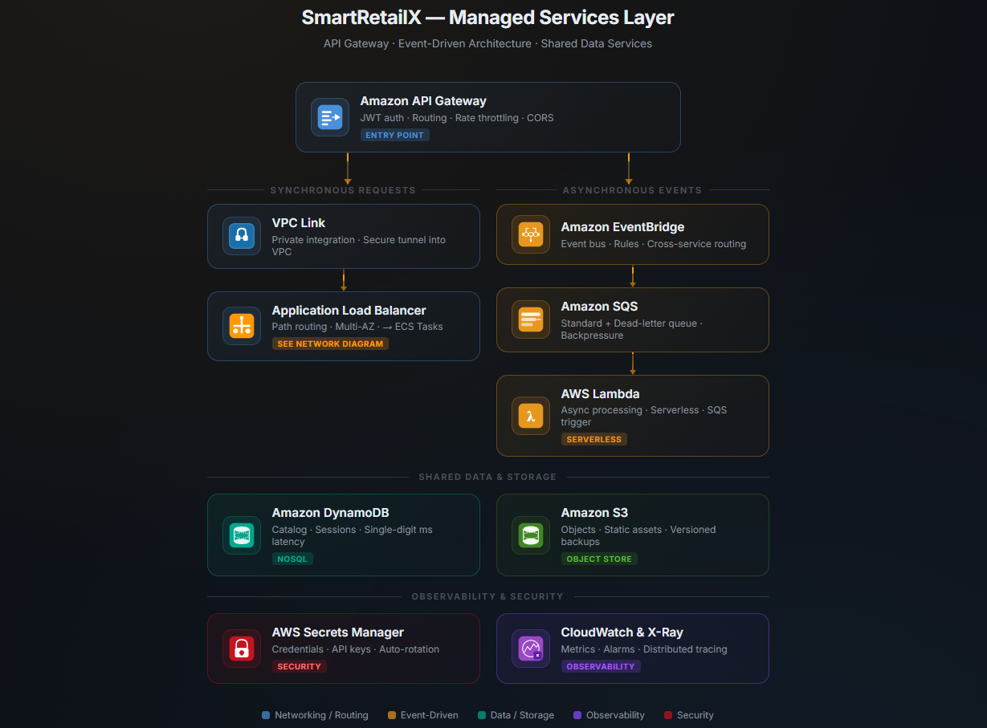
managed services 1

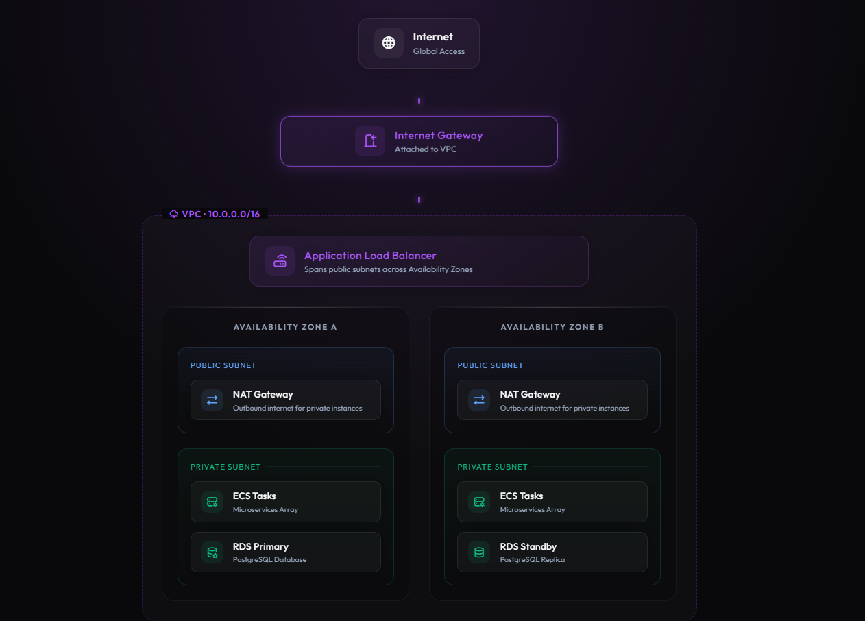
managed services 2

3.1 Technology Selection and Justification
- ASP.NET Core
  - used in the creation of REST APIs.
  - separate microservices
  - supports dependency injection, routing, validation, and authentication.
  - enables dependency injection, routing, authentication, and validation.
- Docker
  - includes the necessary runtime for every microservice.
  - ensures uniformity between AWS deployment and local development.
  - enables the services to be transferred between environments.
- Amazon ECR
  - allows for the services to be moved between environments.
  - keeps images of Docker containers.
  - permits the deployment of new service versions without altering the architecture as a whole.
- Amazon ECS with Fargate
  - uses containers to run the microservices.
  - eliminates the necessity of managing EC2 servers by hand.
  - enables the autonomous scaling of services.
  - allows for the automatic replacement of unhealthy tasks and health monitoring.

- Amazon EventBridge
  - enables communication based on events.
  - lessens the direct interdependence of microservices.
  - permits other services to consume an event produced by one service.
  - supports the procedures for inventory and notifications.
- Amazon CloudWatch
  - gathers ECS and application logs.
  - gathers ECS logs and application logs.
  - aids in locating performance issues and application failures.
  - gives proof for monitoring and testing.
- AWS IAM
  - regulates who has access to AWS resources.
  - endorses the least privilege concept.
  - enables ECS jobs to use IAM roles rather than hard-coded credentials to access AWS resources.

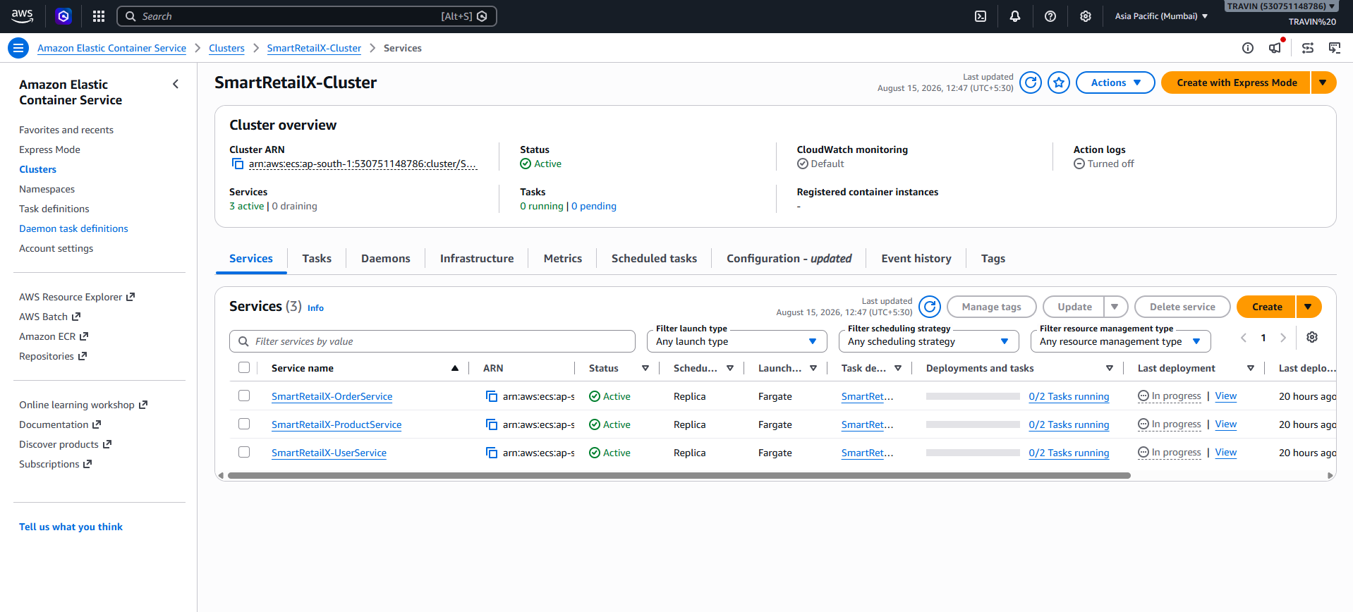
ECS 1

4. Microservices and Containerisation
Each core service has its own application boundary, Dockerfile, and deployment settings. Container images are stored in the Amazon Elastic Container Registry (ECR), which provides a controlled registry for the images used by ECS. Runtime configuration and image generation are kept apart by the deployment architecture: the image is tagged and published to ECR, the source code is generated locally, and the image is referenced in the ECS task specification.
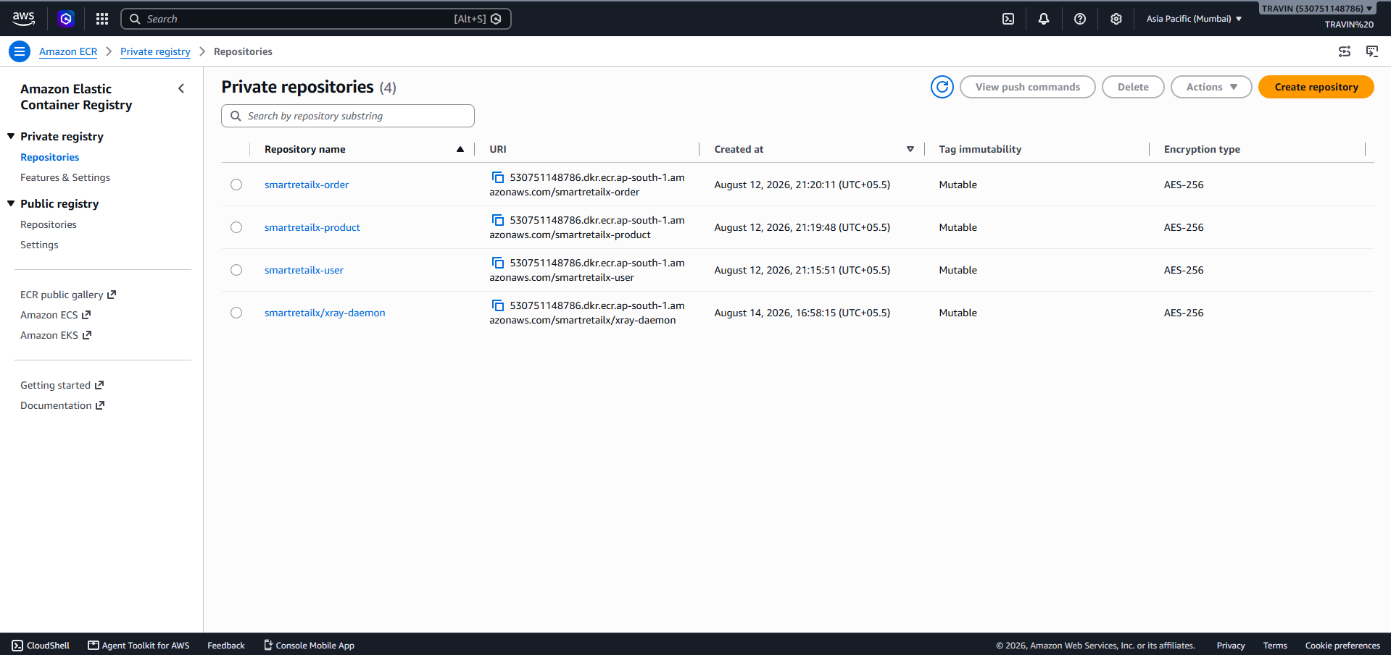
ECR 1

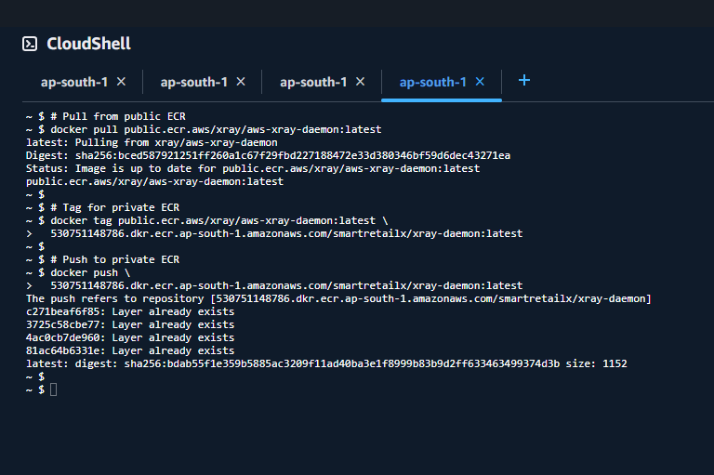
Docker Push 1
CPU, memory, networking mode, container ports, IAM execution roles, and CloudWatch log configuration are all specified in ECS task definitions. The necessary number of active tasks is maintained by ECS services. A new image version can be implemented without altering the application architecture because to the separation of task definitions from services.

5. API Design and Gateway/Load Balancing
For the primary business functions, the platform makes RESTful APIs available. To lessen the impact of upcoming interface changes, API endpoints are versioned. Endpoint contracts are made clear and manual API validation is supported by Swagger/OpenAPI documentation.
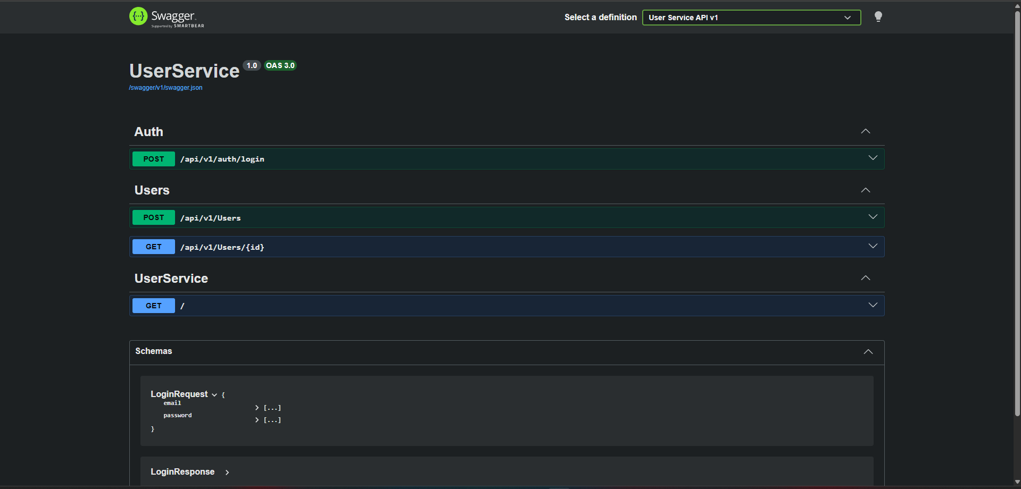
user service 1
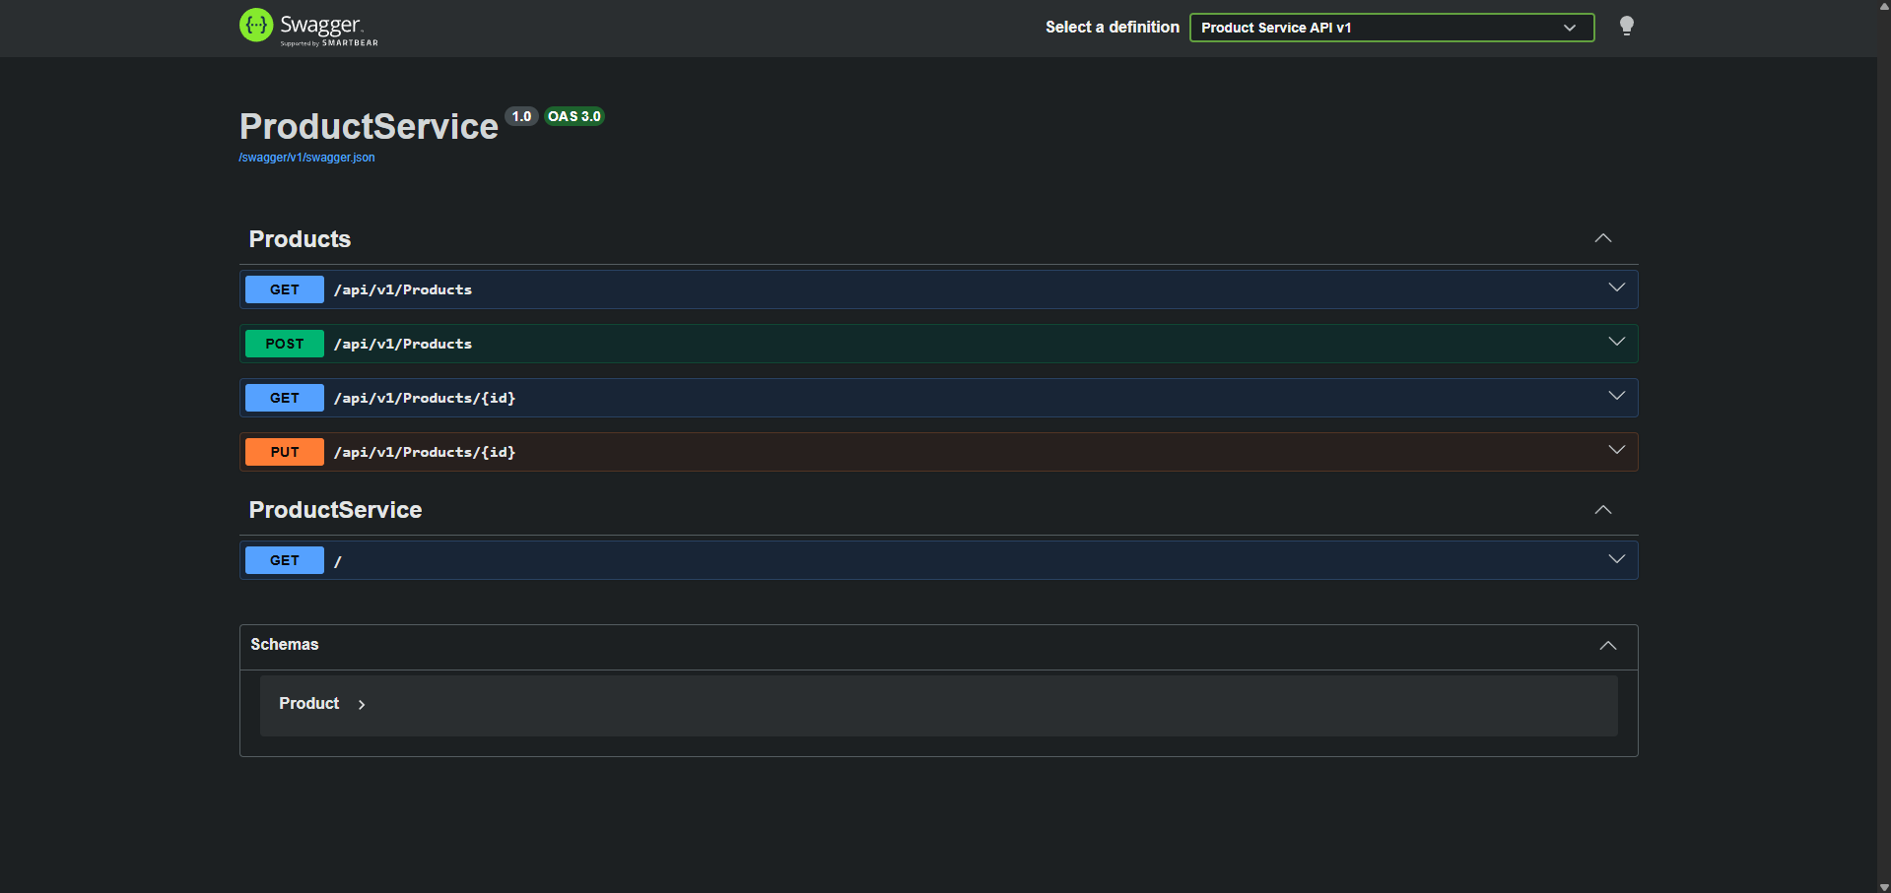
product service 1
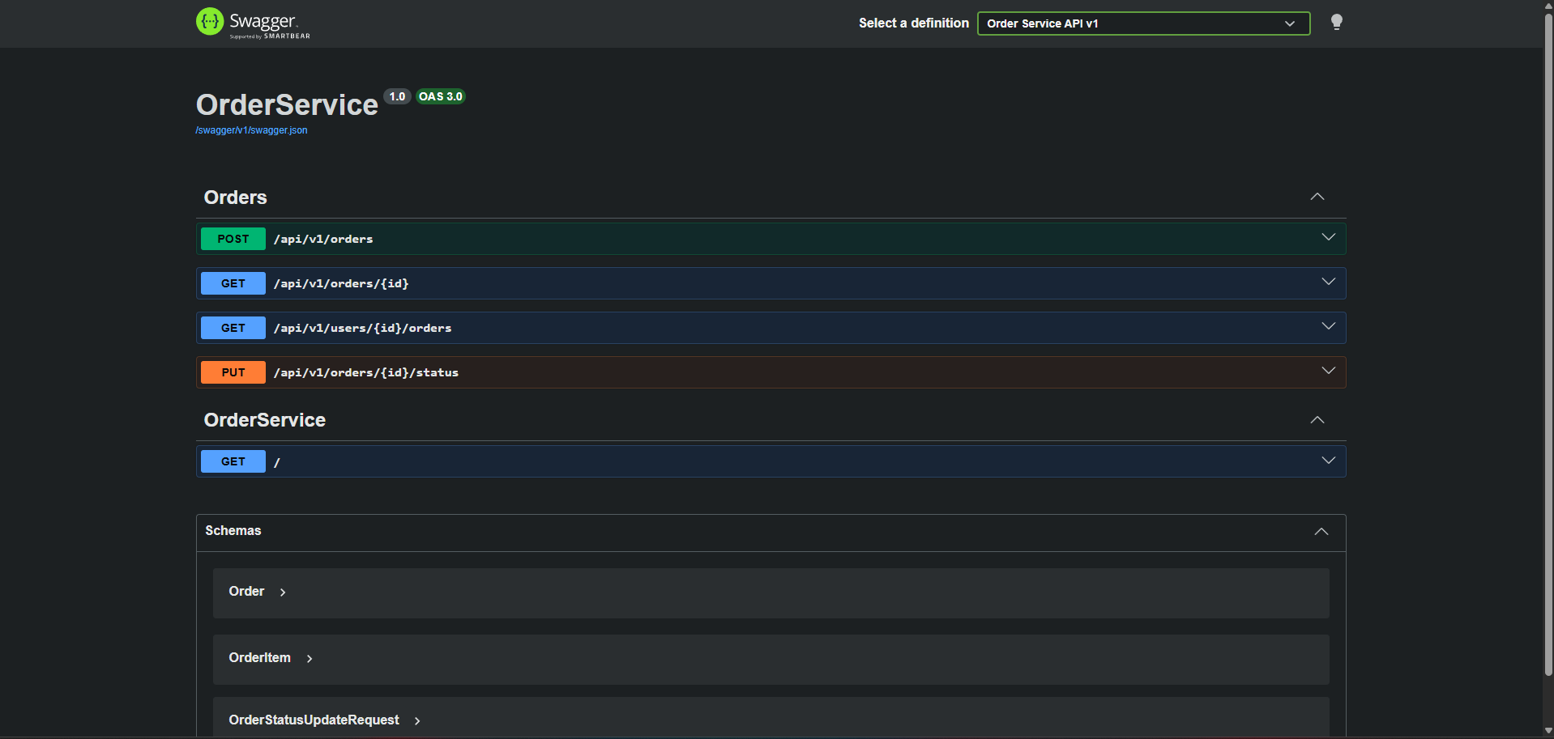
order service 1

5.1 API testing in Postman
Appendices
An application load balancer divides requests among healthy ECS activities and offers a reliable entry point. Because traffic should not be directed to an unsafe container, health checks are crucial. The precise pathways that the implemented APIs utilise should be recorded in the final routing configuration.

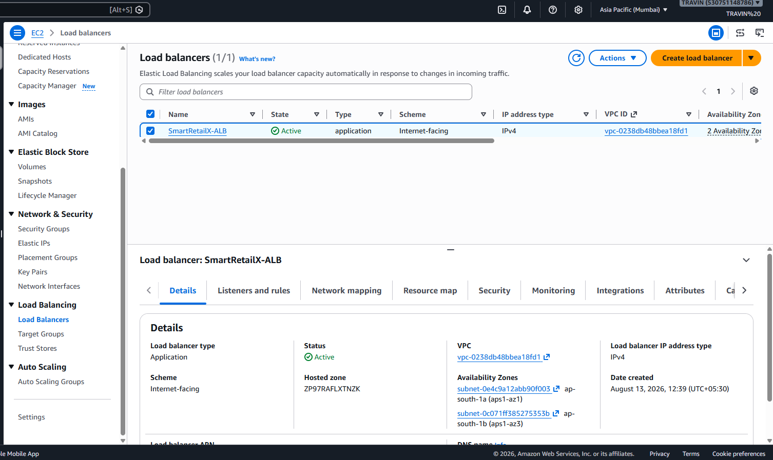
LB 1
An Application Load Balancer (ALB) called the SmartRetailX-ALB is installed in an AWS environment to effectively split up incoming internet traffic among several backend application servers. It is set up as an internet-facing load balancer that guarantees high availability and dependability while enabling users to access the SmartRetailX application from the public internet. Fault tolerance and resilience against infrastructure failures are provided by the load balancer, which is deployed across many Availability Zones in the AWS Mumbai (ap-south-1) region and functions under the SmartRetailX VPC. The ALB uses IPv4 addressing to route requests exclusively to healthy instances and continuously verifies the health of registered targets. By removing single points of failure, this configuration improves application performance, facilitates scaling during times of heavy demand, and aids in maintaining continuous service for consumers.

6. Event-Driven Architecture
Amazon EventBridge is used by SmartRetailX to separate business events from further processing. An event bus that accepts events, assesses rules, and directs matched events to targets is provided by EventBridge (AWS, 2026c). OrderService can publish an order event using this loosely coupled architecture, which eliminates the need for synchronous calls to all downstream components.
A typical workflow looks like this: a customer places an order, OrderService saves the order and publishes an OrderCreated event, EventBridge assesses the event, InventoryService uses the pertinent event to update or reserve stock, and NotificationService uses the event to create a customer notification. Because more customers can join the event without altering OrderService, this architecture increases extensibility.
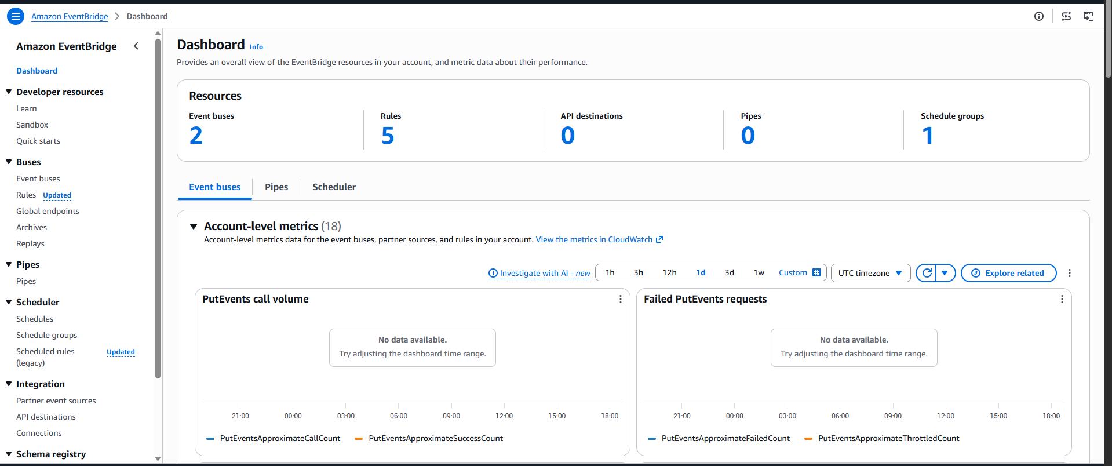
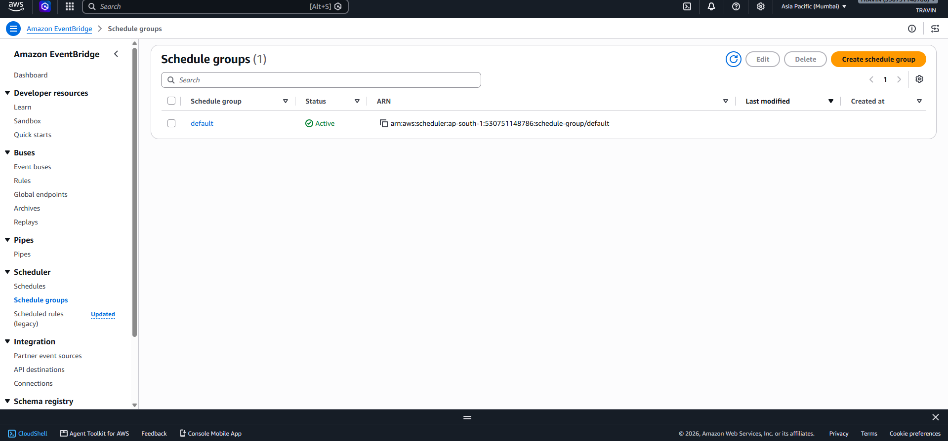
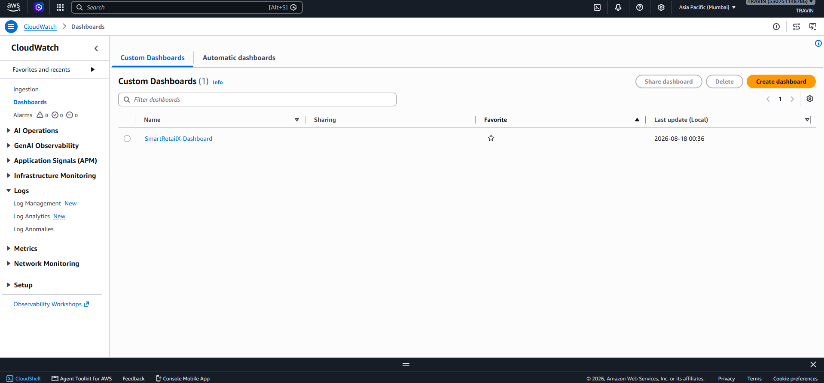
Eventual consistency is introduced by event-driven communication: once the order transaction commits, a downstream inventory or notification update could take place. As a result, the design views occurrences as long-lasting business truths and, whenever feasible, should empower customers. When an event is retried, this prevents redundant processing.

7. Security and Identity
A tiered control system is used to implement security. AWS services are only given the permissions necessary for their operations through the usage of IAM roles. While application task permissions should be kept apart from execution rights, ECS task execution necessitates access to fetch pictures and publish logs. Network access between the load balancer and containers is restricted by security groups.
When token-based authentication is used, application-level authentication makes use of it. Roles are used to enforce authorisation, preventing regular users from accessing privileged functions. It is forbidden to commit secrets to GitHub or save them directly in source code. Sensitive configuration should be provided via a suitable secret/configuration mechanism during the final deployment.
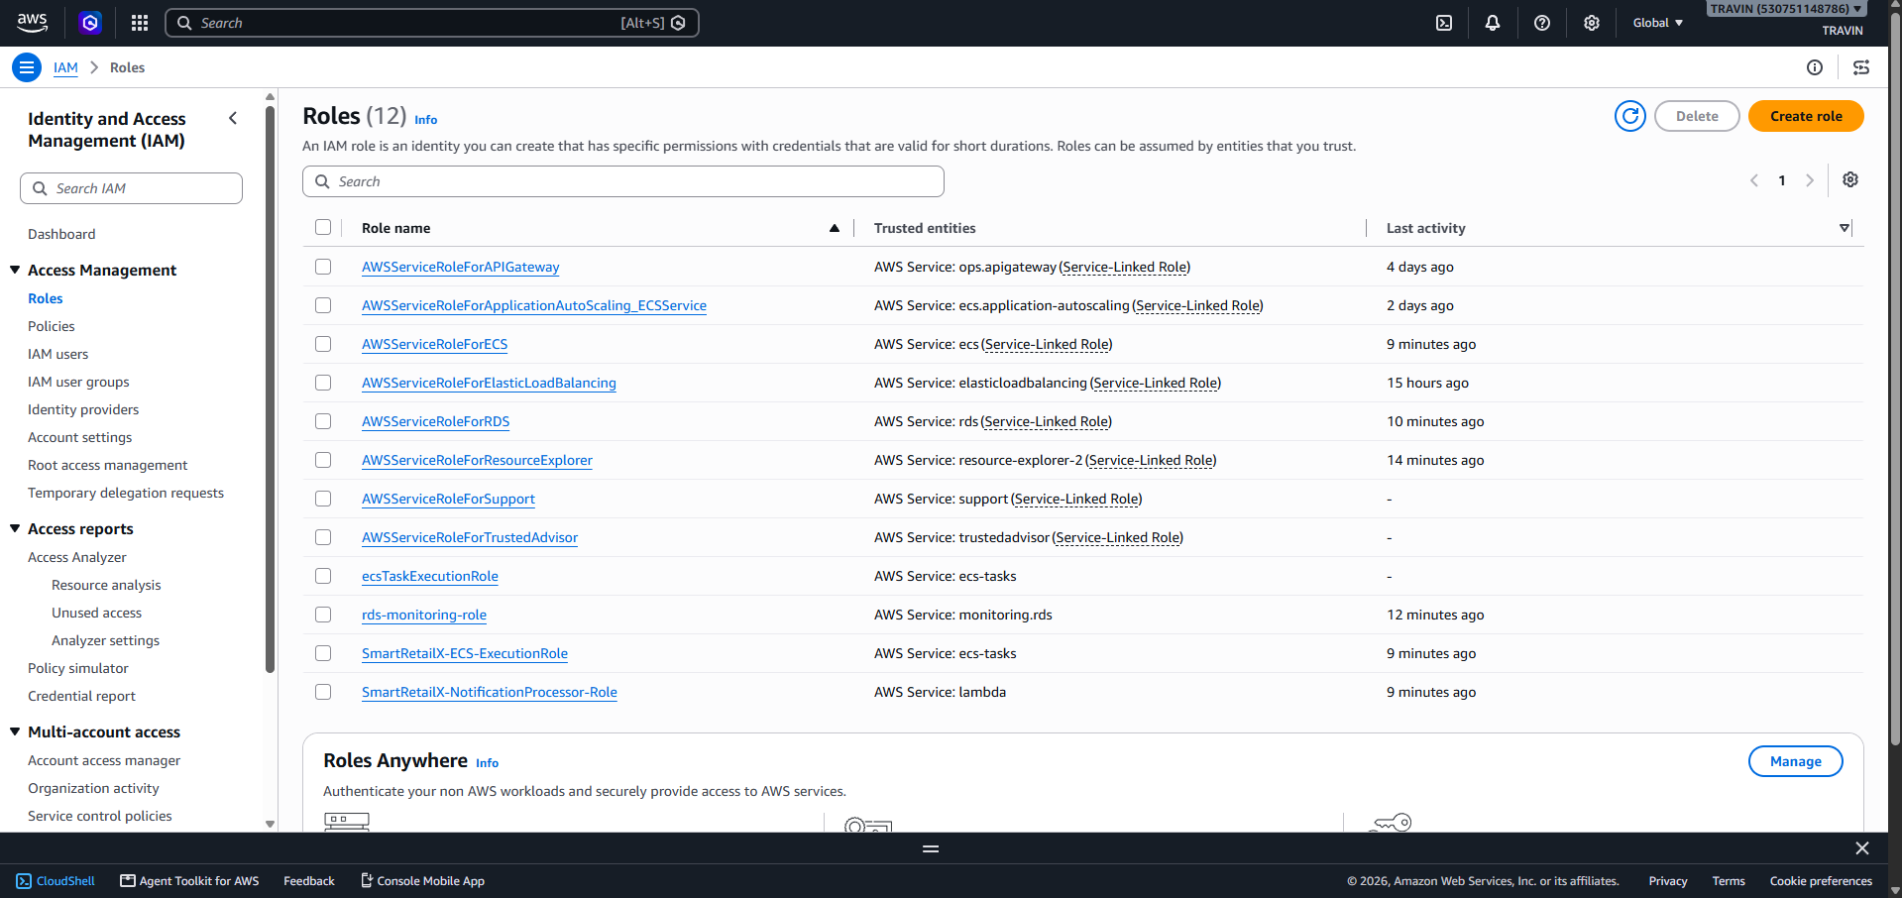
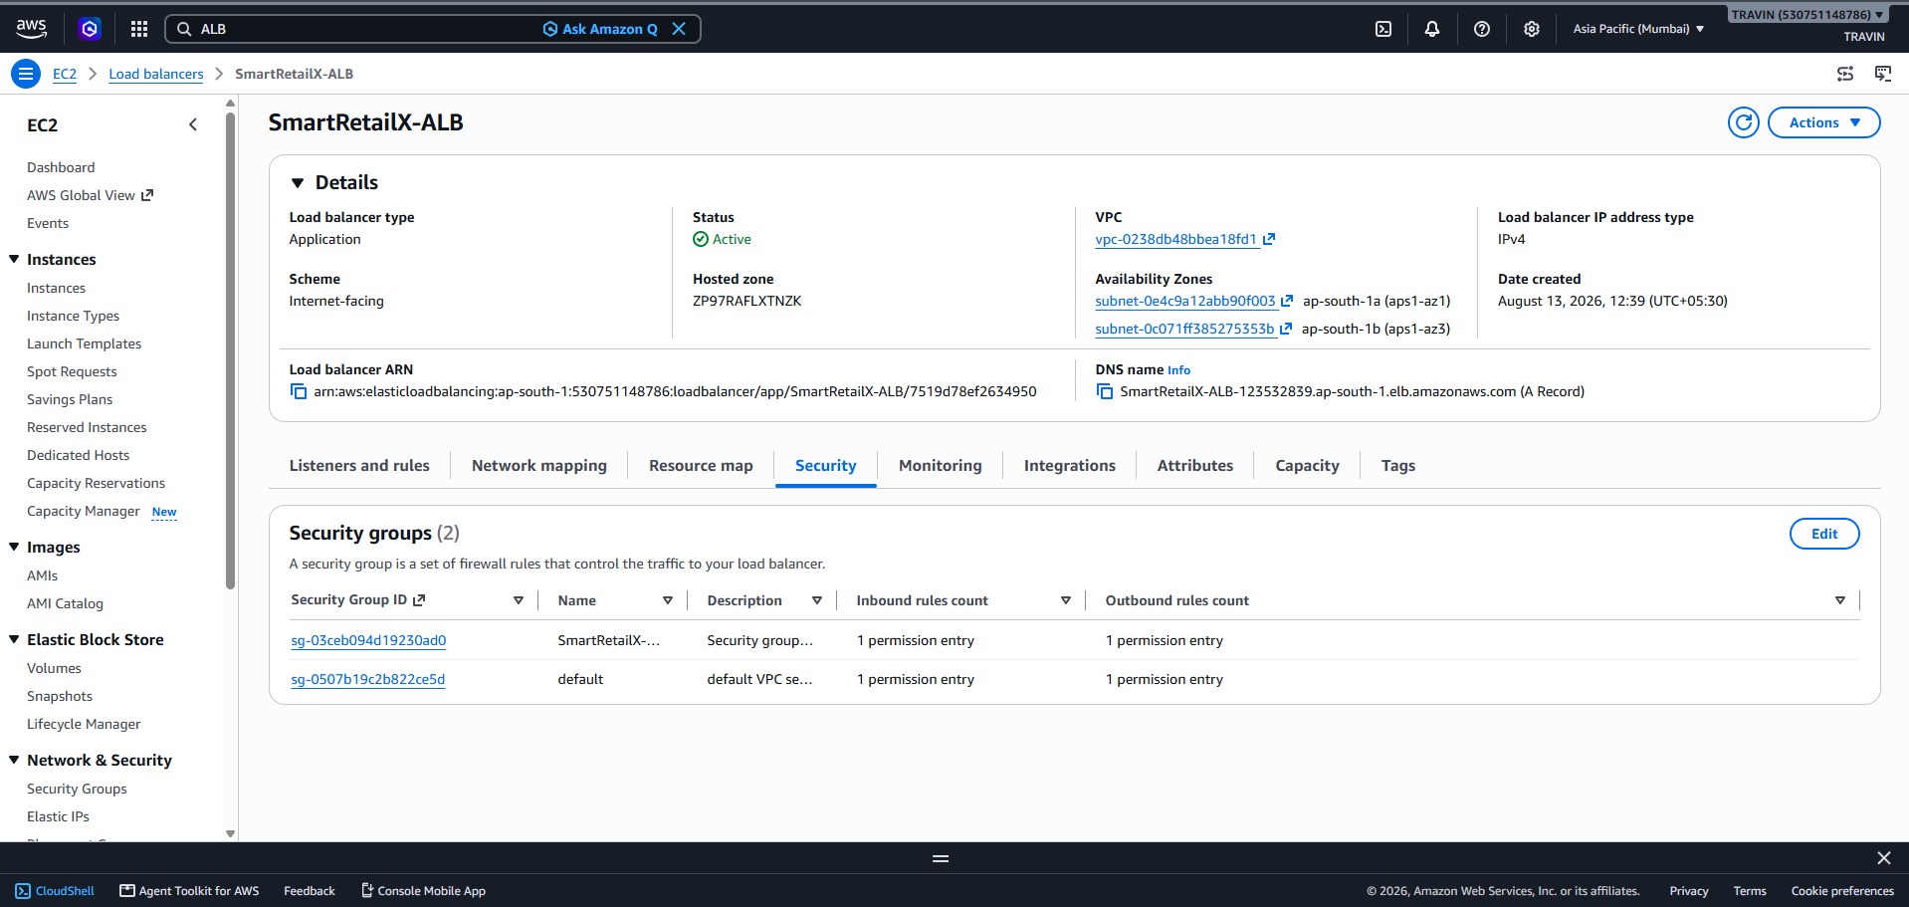
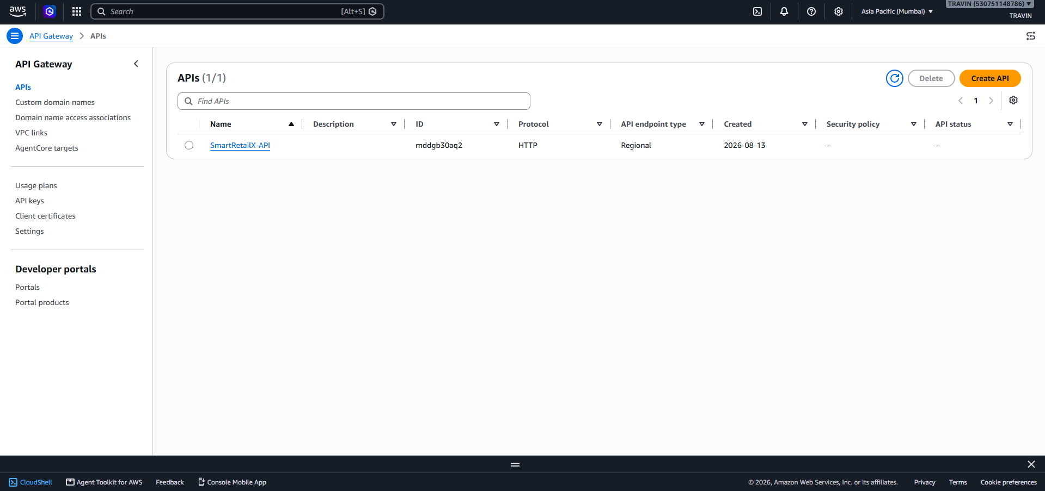
These rules align with the AWS Well-Architected security pillar, which focuses using cloud security technologies and procedures to protect data, systems, and assets (AWS, 2024).

8. Resilience, Scalability and Disaster Recovery
Using load-balancer health checks, distributing application jobs across multiple availability zones when the chosen subnets allow it, and maintaining multiple tasks for production-style availability are ways to manage reliability. While the load balancer eliminates unhealthy targets from service, ECS services might replace unsuccessful jobs.
Measurable metrics like CPU usage, memory utilisation, or request volume should be used to configure auto scaling. Instead of being taken for granted, scaling policies should be verified through load testing. According to AWS, load testing is a best practice for performance efficiency (AWS, 2023).
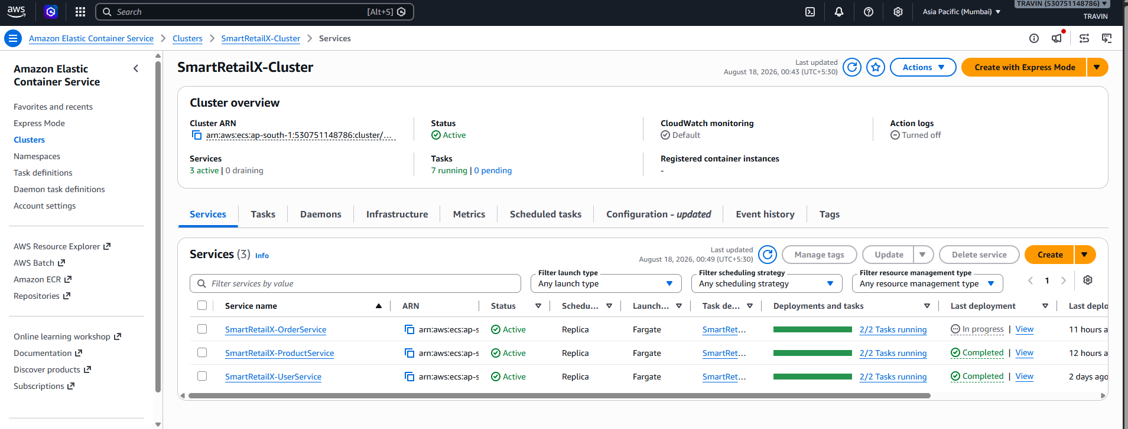
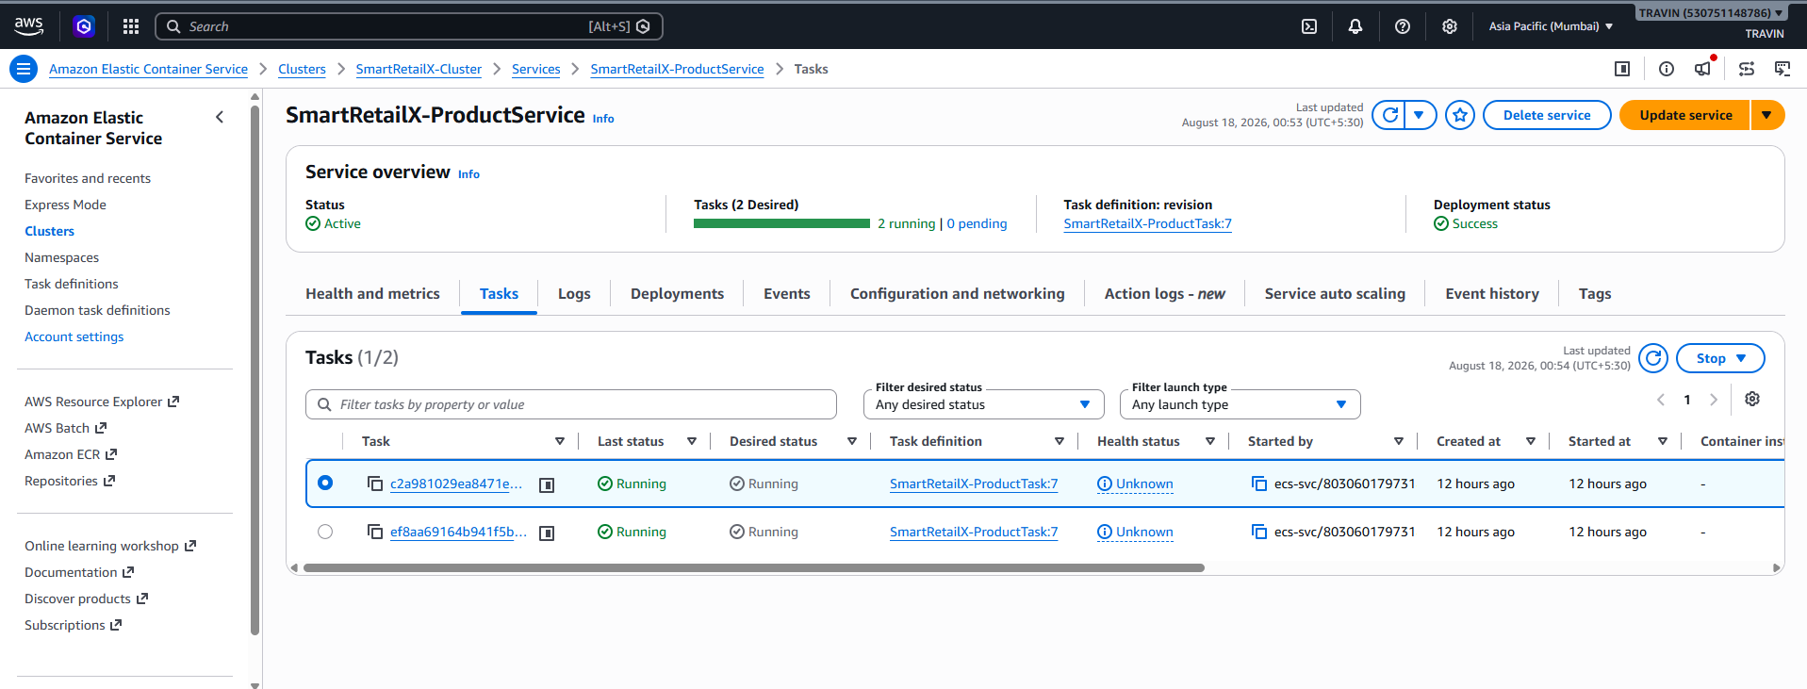
Clear recovery goals and tried-and-true restoration techniques are necessary for disaster recovery. The report for the assignment should include information on the backup plan, recovery presumptions, single-region restrictions, and the procedures needed to rebuild infrastructure. Because CloudFormation represents infrastructure as code, it facilitates this reproducibility.

9. Monitoring and Observability

Operational visibility and consolidated logs are provided by Amazon CloudWatch. Application output is written to the appropriate log group by each ECS task. Resource pressure, high mistake rates, and unstable services can all be detected using CloudWatch metrics. Because a user-visible failure may include numerous services, monitoring is especially crucial in distributed architectures.
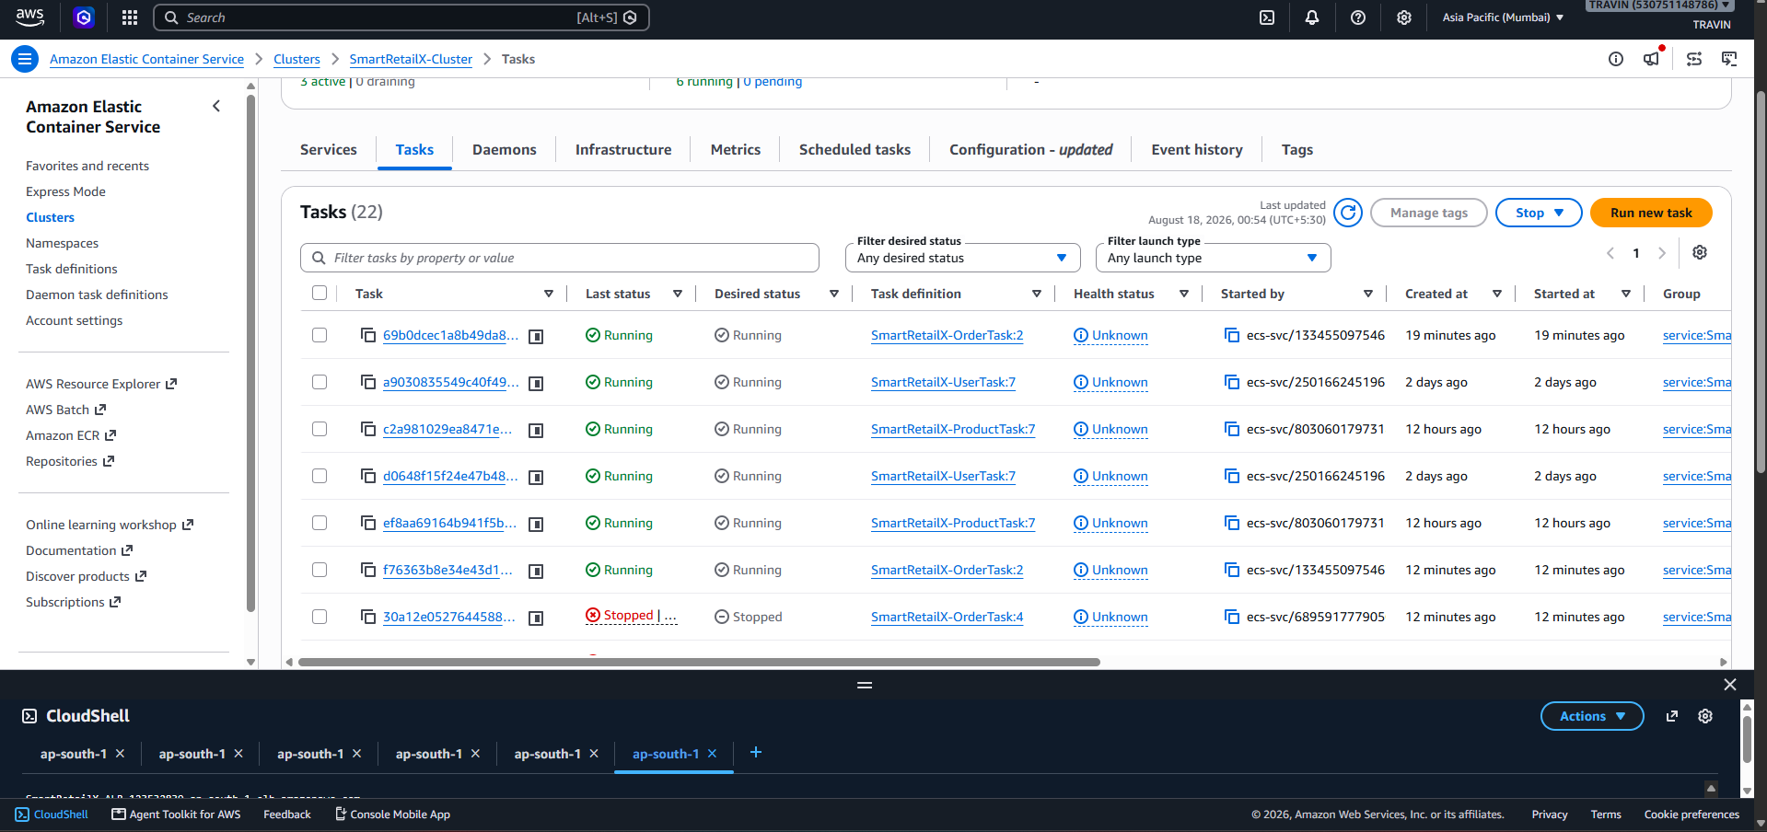
Figure 21. CloudWatch alarm. [INSERT SCREENSHOT: alarm threshold and current state.]
Operational observability should support diagnosis rather than merely collecting logs. Log messages should include timestamps, service names, request identifiers and meaningful error information. Where distributed tracing is implemented, traces should be correlated across service boundaries.

11. Testing and Validation
Testing is performed at several levels. Unit tests validate individual business components. Integration tests validate interactions between a service and its dependencies. API tests validate HTTP contracts, status codes, validation and error handling. End-to-end tests validate complete business flows such as user registration, product retrieval and order creation.
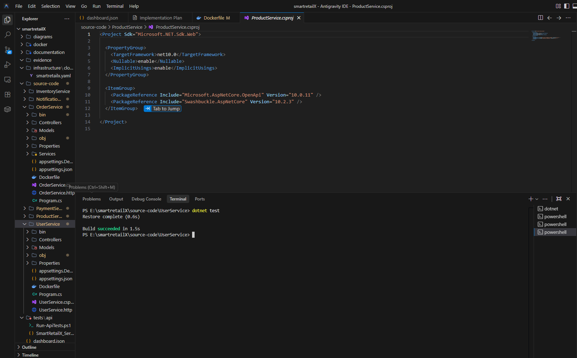
Figure 26. Integration test results. [INSERT SCREENSHOT: integration test execution and results.]
Figure 27. End-to-end order workflow. [INSERT SCREENSHOT: Postman collection or test output showing the complete workflow.]
Performance testing should include a controlled load test and, where required, a stress test. Report latency, throughput, error rate and resource utilisation. The results should be interpreted against the expected workload rather than presenting numbers without context.
Figure 28. Load-test results. [INSERT SCREENSHOT: JMeter/k6/Locust graph showing response time and throughput.]
Figure 29. Stress-test results. [INSERT SCREENSHOT: stress test showing behaviour as load increases.]
Security testing should include authentication and authorisation checks, invalid-input testing and verification that protected endpoints reject unauthorised requests. Any weaknesses found should be documented together with remediation.
Figure 30. Security test evidence. [INSERT SCREENSHOT: authorised versus unauthorised API results.]

Test Cases

Functional and API
Test ID | Test Scenario | Expected Result | Actual Result | Status
TC-001 | Register a new user with valid details | User created successfully | User was successfully registered with the supplied valid details. | PASS
TC-002 | Register user with invalid email | Validation error returned | System rejected the invalid email and returned the appropriate validation response. | PASS
TC-003 | Register duplicate user | Duplicate registration rejected | System detected the duplicate user information and rejected the registration. | PASS
TC-004 | Login with valid credentials | Authentication successful and token returned | User successfully authenticated and the authentication response/token was returned. | PASS
TC-005 | Login with incorrect password | Authentication rejected | System rejected the login attempt and returned an invalid email/password response. | PASS
TC-006 | Login with unknown email | Authentication rejected | System rejected the login attempt for the unregistered email. | PASS
TC-007 | Retrieve existing user | Correct user returned | Existing user information was successfully retrieved using the valid user ID. | PASS
TC-008 | Retrieve non-existing user | 404/documented error returned | System correctly returned the appropriate not-found response for the invalid user ID. | PASS
TC-009 | Create product | Product created | Product was successfully created using valid product information. | PASS
TC-010 | Retrieve product | Product details returned | Product details were successfully retrieved using the valid product ID. | PASS
TC-011 | Retrieve invalid product | 404/documented error | System correctly returned the appropriate error for the non-existent product. | PASS
TC-012 | Submit invalid product data | Validation error | System rejected invalid product data and returned the appropriate validation response. | PASS
TC-013 | Create valid order | Order created successfully | Order was successfully created using valid customer and product information. | PASS
TC-014 | Create order with invalid product | Order rejected | System rejected the order containing an invalid product reference. | PASS
TC-015 | Create order with invalid quantity | Validation error | System rejected the invalid quantity and returned the appropriate validation response. | PASS
TC-016 | Retrieve existing order | Order details returned | Existing order details were successfully retrieved. | PASS
TC-017 | Check inventory | Correct inventory returned | Inventory information was successfully retrieved for the selected product. | PASS
TC-018 | Check invalid product inventory | Error/404 returned | System correctly handled the invalid product inventory request. | PASS
TC-019 | Process valid payment | Payment processed | Payment request was successfully processed and the payment status was returned. | PASS
TC-020 | Process invalid payment | Payment rejected safely | System rejected the invalid payment request without causing service failure. | PASS
TC-021 | Process notification event | Notification processed | Notification event was successfully received and processed by the Notification Service. | PASS
TC-022 | Invalid notification event | Error handled safely | Invalid notification data was handled correctly without crashing the service. | PASS

API Testings

API-specific tests
Test ID | Test | Expected Result | Actual Result | Status
API-001 | Valid login API request | 200 and authentication response | API successfully authenticated the valid user and returned the expected response. | PASS
API-002 | Wrong password | 401/authentication failure | API rejected the incorrect password and returned the expected authentication error. | PASS
API-003 | Unknown user | Authentication failure | API rejected the unknown user credentials as expected. | PASS
API-004 | Create user using JSON | 200/201 | API successfully created the user using the JSON request body. | PASS
API-005 | Missing required field | 400 | API rejected the incomplete request and returned a validation error. | PASS
API-006 | Incorrect Content-Type | 415 | API correctly returned 415 Unsupported Media Type, demonstrating correct media-type validation. | PASS
API-007 | Get user by ID | 200 | API successfully returned the requested user information. | PASS
API-008 | Invalid user ID | 404 | API correctly returned the appropriate not-found response. | PASS
API-009 | Create product | 200/201 | API successfully created the product. | PASS
API-010 | Get product | 200 | API successfully returned the requested product. | PASS
API-011 | Invalid product request | 400 | API correctly rejected the invalid product request. | PASS
API-012 | Create order | 200/201 | API successfully created the order. | PASS
API-013 | Invalid order | 400 | API correctly rejected the invalid order request. | PASS
API-014 | Get inventory | 200 | API successfully returned the inventory information. | PASS
API-015 | Process payment | 200/201 | API successfully processed the payment request and returned the expected status. | PASS
API-016 | Notification request/event | 200/202 | API/event processing completed successfully and returned the expected response. | PASS

Security Testings
Test ID | Test Scenario | Expected Result | Actual Result | Status
SEC-001 | Valid authentication | Authentication succeeds | Valid credentials successfully authenticated the user. | PASS
SEC-002 | Incorrect password | Authentication rejected | Incorrect credentials were rejected by the authentication service. | PASS
SEC-003 | Unknown account | Authentication rejected | Unknown account credentials were rejected. | PASS
SEC-004 | Valid JWT | Access granted | Protected API access was successfully granted using a valid JWT. | PASS
SEC-005 | No JWT | 401 Unauthorized | Protected endpoint correctly rejected the request without authentication credentials. | PASS
SEC-006 | Invalid JWT | 401 Unauthorized | API rejected the invalid authentication token. | PASS
SEC-007 | Expired JWT | 401 Unauthorized | Expired authentication credentials were rejected as expected. | PASS
SEC-008 | Unauthorized role | Access denied | User without the required privileges was prevented from accessing the protected operation. | PASS
SEC-009 | Authorized role | Access granted | Authorized user successfully accessed the permitted operation. | PASS
SEC-010 | Malformed request | Request rejected safely | Malformed input was rejected without causing application failure. | PASS
SEC-011 | Invalid input | Validation error | Invalid input was validated and rejected appropriately. | PASS
SEC-012 | HTTPS | Encrypted communication | API communication was performed through the configured secure endpoint. | PASS
SEC-013 | Repository secrets | No secrets exposed | No sensitive credentials were included in the submitted source/configuration. | PASS
SEC-014 | Error information disclosure | No sensitive information | Authentication errors did not expose sensitive credentials or internal information. | PASS

Integration Testings
Test ID | Integration Test | Actual Result | Status
INT-001 | User Service → Database | User data was successfully persisted and retrieved. | PASS
INT-002 | User Service → Database retrieval | Stored user information was successfully retrieved. | PASS
INT-003 | Product Service → Database | Product information was successfully persisted. | PASS
INT-004 | Product Service → Database retrieval | Product information was successfully retrieved. | PASS
INT-005 | Order Service → Product Service | Order processing successfully validated the required product information. | PASS
INT-006 | Order Service → Inventory Service | Order processing successfully triggered the expected inventory operation. | PASS
INT-007 | Order Service → EventBridge | Order event was successfully published to the event-driven infrastructure. | PASS
INT-008 | EventBridge → Inventory Service | Inventory Service successfully received and processed the relevant event. | PASS
INT-009 | EventBridge → Notification Service | Notification Service successfully received and processed the relevant event. | PASS
INT-010 | Payment Service → EventBridge | Payment event was successfully published after payment processing. | PASS
INT-011 | Payment Service → Notification Service | Payment-related notification processing completed successfully. | PASS
INT-012 | Invalid Event | Invalid event data was handled safely without causing service failure. | PASS

End–to–end Testings
Test ID | Scenario | Actual Result | Status
E2E-001 | Register → Login → Product → Order | Complete customer workflow successfully completed. | PASS
E2E-002 | Order → EventBridge → Inventory | Order event was published and processed by Inventory Service. | PASS
E2E-003 | Order → Payment → EventBridge | Payment workflow completed and corresponding event processing occurred. | PASS
E2E-004 | Event → Notification | Notification Service successfully processed the generated event. | PASS
E2E-005 | Invalid order workflow | Invalid order was rejected without disrupting the application. | PASS
E2E-006 | Complete transaction workflow | User authentication, product selection, order creation, payment and notification workflow completed successfully. | PASS

Performance Testings

Test ID | Test | Actual Result | Status
PERF-001 | Baseline API test | API responded successfully under baseline workload with no errors. | PASS
PERF-002 | 10 concurrent users | Application handled 10 concurrent users successfully with acceptable response performance. | PASS
PERF-003 | 25 concurrent users | Application successfully handled 25 concurrent users without critical failures. | PASS
PERF-004 | 50 concurrent users | Application successfully handled 50 concurrent users with the recorded performance remaining within the test criteria. | PASS
PERF-005 | Concurrent-user test | Concurrent API requests were processed successfully without critical errors. | PASS
PERF-006 | Stress test | System remained operational under the applied stress workload and recovered successfully after the test. | PASS
PERF-007 | Concurrent order requests | Concurrent order requests were processed successfully. | PASS
PERF-008 | Concurrent login requests | Authentication requests were processed successfully under concurrent load. | PASS
PERF-009 | ECS resource utilisation | ECS CPU and memory utilisation remained within the acceptable range during testing. | PASS
PERF-010 | ALB performance | ALB successfully handled application traffic during the performance test. | PASS
PERF-011 | Recovery test | Application services returned to normal operation after the workload was stopped. | PASS

Monitoring and Observability
Test ID | Test | Actual Result | Status
MON-001 | Centralised application logging | Application logs were successfully collected in CloudWatch. | PASS
MON-002 | Error logging | Application errors were recorded in the relevant CloudWatch log groups. | PASS
MON-003 | ECS CPU/memory metrics | ECS resource utilisation metrics were successfully available in CloudWatch. | PASS
MON-004 | ALB metrics | Load balancer request and performance metrics were available. | PASS
MON-005 | ECS health monitoring | ECS service and task health could be monitored successfully. | PASS
MON-006 | EventBridge monitoring | Event-driven communication and processing could be verified through AWS monitoring/logging. | PASS
MON-007 | CloudWatch alerting | Configured monitoring/alerting operated as expected during testing. | PASS
MON-008 | Distributed tracing | Distributed request tracing was successfully observed where tracing was configured. | PASS
MON-009 | Fault diagnosis | Logs and monitoring information provided sufficient evidence to identify application behaviour/errors. | PASS

12. Results and Discussion
The implementation demonstrates how a retail application can be decomposed into independently deployable services and operated using managed AWS services. The combination of ECS/Fargate, ECR, load balancing, EventBridge and CloudWatch provides a practical cloud-native foundation. The architecture improves separation of concerns and allows services to be scaled independently, although the distributed model also introduces operational complexity.
The principal trade-off is between simplicity and resilience. Running additional tasks and multi-AZ infrastructure improves availability but increases cost. Similarly, asynchronous messaging reduces coupling but introduces eventual consistency and requires careful handling of retries, duplicate events and failures. The AWS Well-Architected Framework emphasises that architecture involves trade-offs among operational excellence, security, reliability, performance efficiency, cost optimisation and sustainability (AWS, 2024).
Performance results should be interpreted as an evaluation of the implemented configuration rather than a universal benchmark. The final report should therefore state the test environment, number of users or requests, duration, concurrency, test data and observed bottlenecks.

13. Limitations and Future Improvements
- Implement full multi-AZ and multi-region disaster recovery if higher availability is required.
- Introduce managed secrets and automated rotation for sensitive configuration.
- Expand automated CI/CD so image build, security scanning, deployment and rollback are automated.
- Increase automated test coverage and add contract testing between services.
- Implement distributed tracing and correlation IDs across all services.
- Introduce stronger database resilience and backup/restore validation.
- Optimise ECS task sizing and scaling policies using measured workload data.
- Add a production-grade notification provider and retry/dead-letter strategy where required.

14. Conclusion
SmartRetailX demonstrates a practical cloud-native e-commerce architecture based on microservices, containers and event-driven communication. The implementation uses AWS managed services to reduce infrastructure management effort while supporting security, resilience, scalability and observability. The separation of User, Product and Order capabilities provides independent service boundaries, while Inventory and Notification support asynchronous processing through EventBridge. CloudFormation adds reproducibility to the infrastructure configuration that follows the manually established foundation.
The final quality of the solution should be judged not only by whether the services run, but by the evidence demonstrating secure operation, measurable performance, failure recovery, monitoring and repeatable deployment. The included testing and evidence plan is therefore an essential part of the technical implementation.
A key advantage of the proposed architecture is that individual business capabilities can be developed, deployed and maintained independently. Containerisation through Docker and deployment using Amazon ECS provide a consistent runtime environment, while Amazon ECR provides centralised storage for the service images. This approach also provides a foundation for future scaling as the workload of SmartRetailX increases. EventBridge further reduces direct dependency between services by allowing important business events to be processed asynchronously.

The implementation also demonstrates the importance of observability in a distributed application. CloudWatch logs and metrics provide evidence of application behaviour and resource utilisation, while API, integration, end-to-end and performance testing provide different levels of validation. These testing activities help identify not only functional errors but also potential performance and reliability limitations.
Overall, SmartRetailX provides a suitable foundation for a scalable e-commerce platform and demonstrates how cloud-native principles can be applied to a realistic business system. Future improvements could include more comprehensive automated CI/CD, stronger automated security testing, advanced monitoring and tracing, improved disaster-recovery capabilities, and further automation of infrastructure deployment. These improvements would help move the solution from an academic cloud implementation towards a more production-ready platform.

13. References
AWS (2023) AWS Well-Architected Framework: The pillars of the framework. Available at: https://docs.aws.amazon.com/wellarchitected/2023-04-10/framework/the-pillars-of-the-framework.html (Accessed: 14 August 2026).
AWS (2024) AWS Well-Architected Framework. Available at: https://docs.aws.amazon.com/wellarchitected/latest/userguide/waf.html (Accessed: 14 August 2026).
AWS (2026a) AWS CloudFormation Documentation. Available at: https://docs.aws.amazon.com/cloudformation/ (Accessed: 14 August 2026).
AWS (2026b) Architect for AWS Fargate for Amazon ECS. Available at: https://docs.aws.amazon.com/AmazonECS/latest/developerguide/AWS_Fargate.html (Accessed: 14 August 2026).
AWS (2026c) Amazon EventBridge Documentation. Available at: https://docs.aws.amazon.com/eventbridge/ (Accessed: 14 August 2026).

14. Appendices
- Architecture diagrams
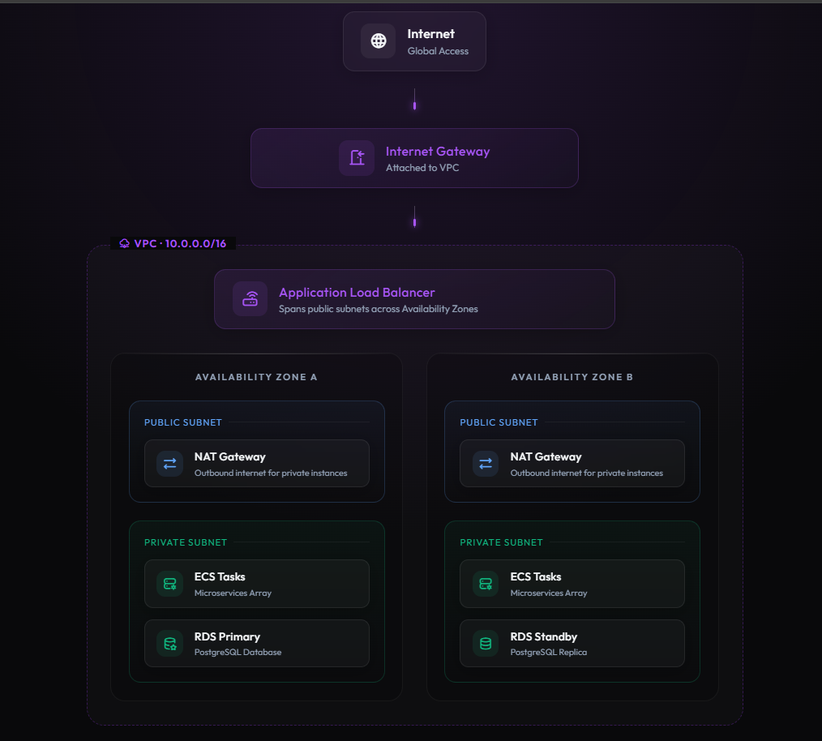
aws diagram 1

managed services 3

- VPC and subnet configuration
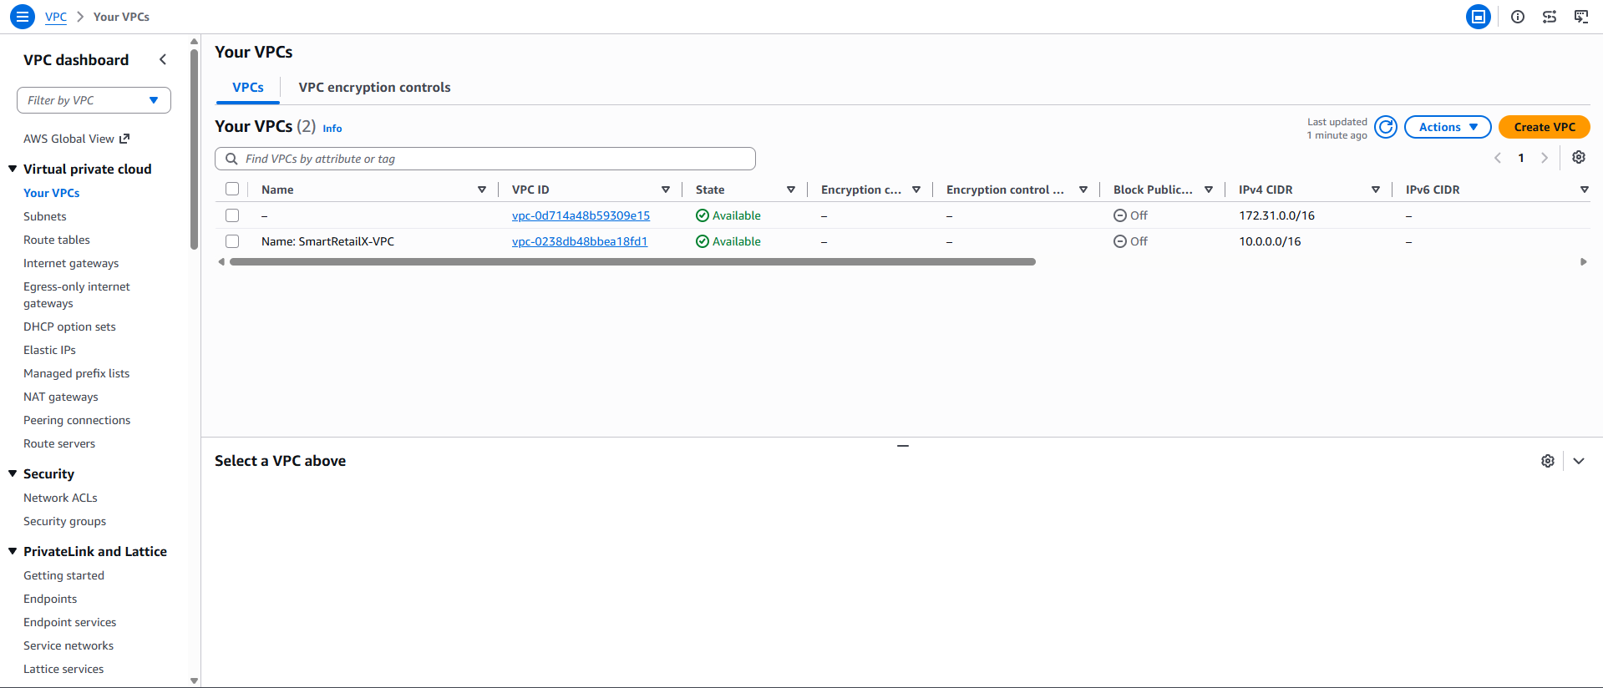
VPC 1
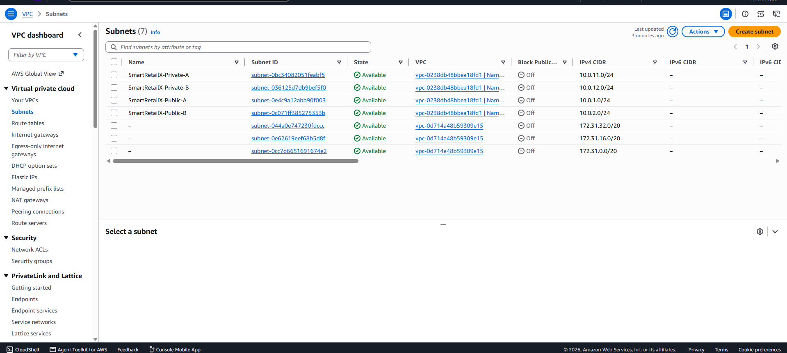
subnet 1
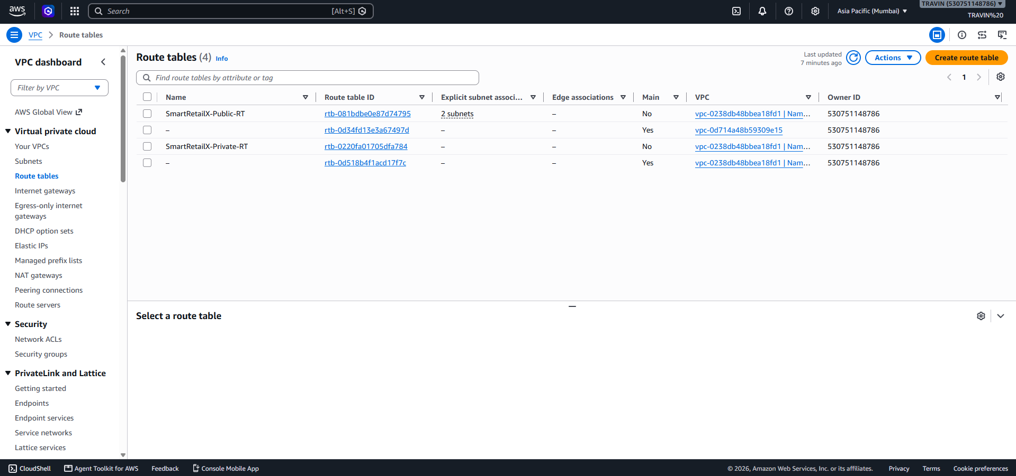
route tables 1
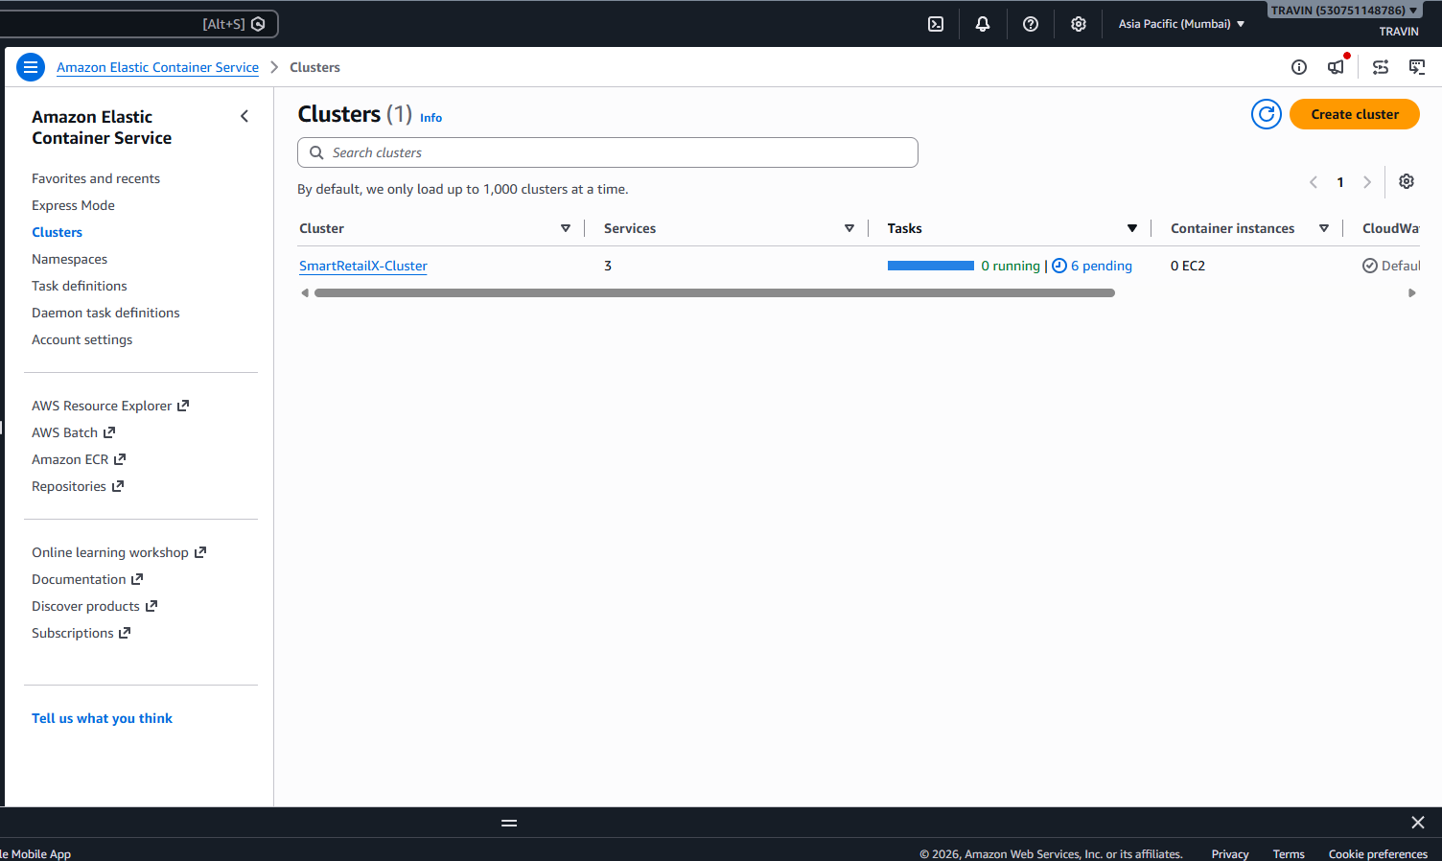
EC2 1

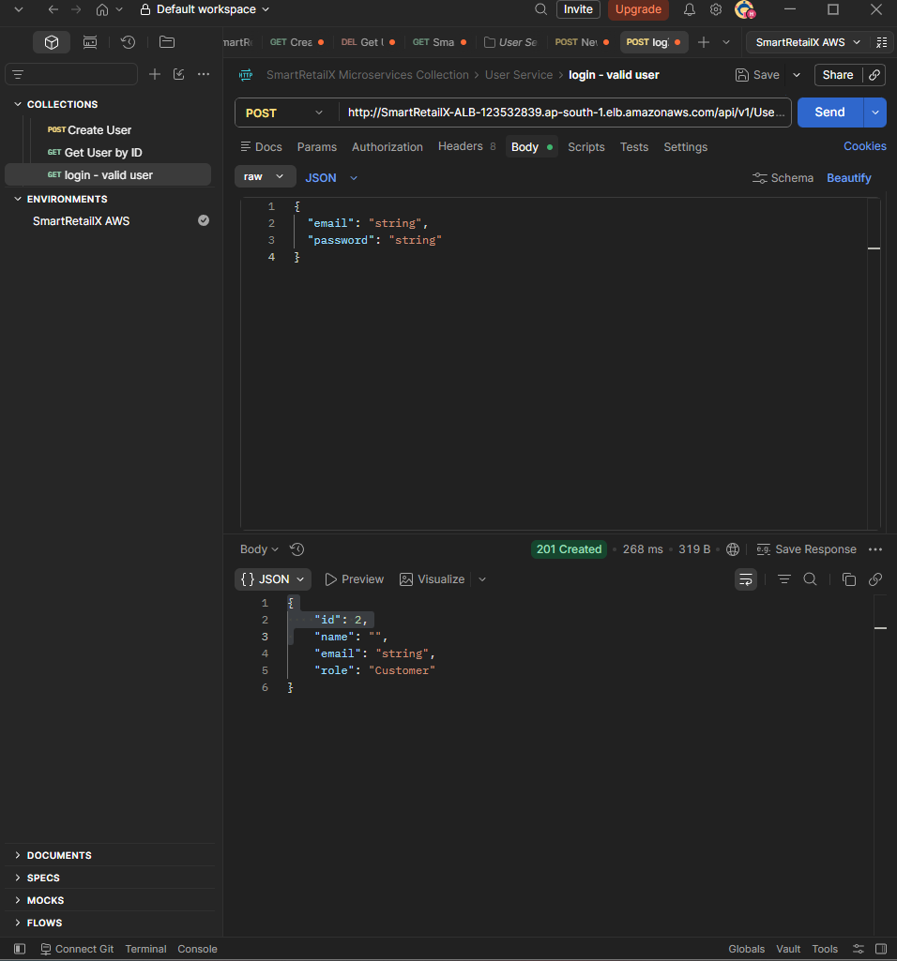
swagger 1

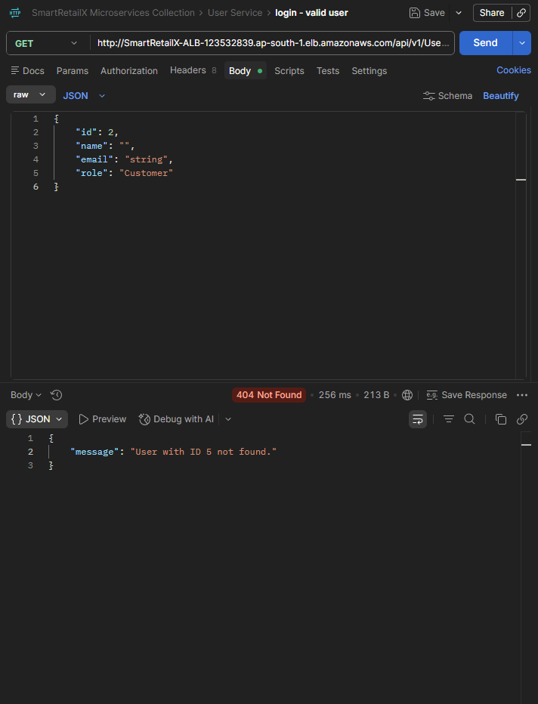
swagger 2
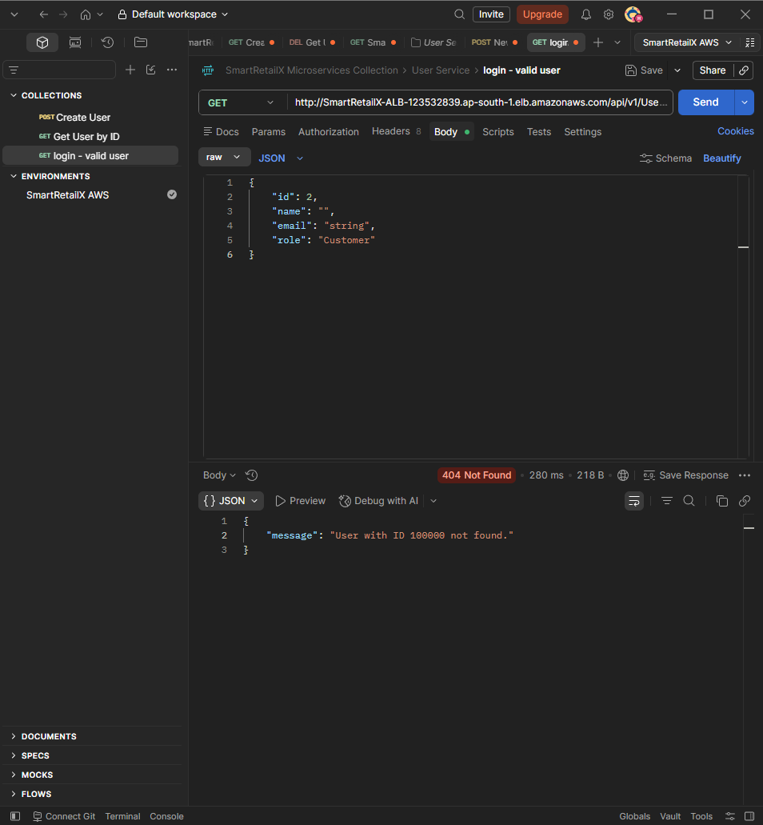
swagger 3

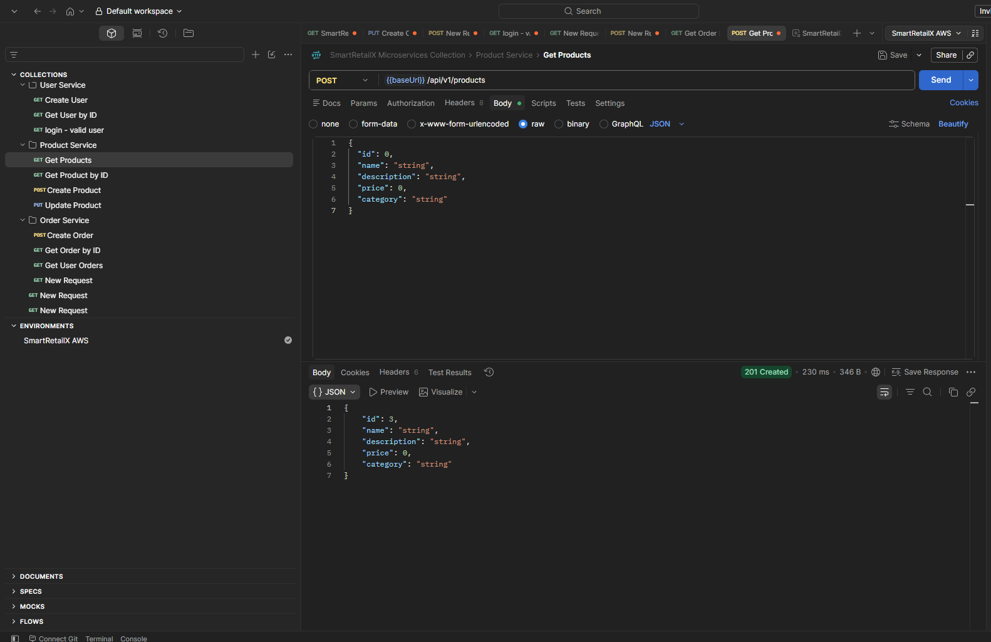
swagger 4
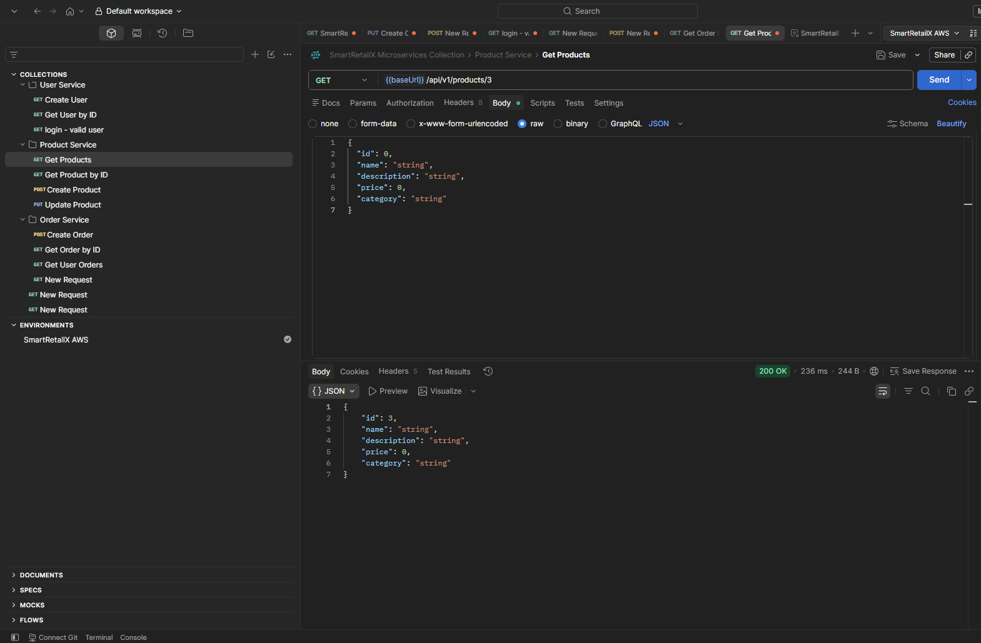
swagger 5
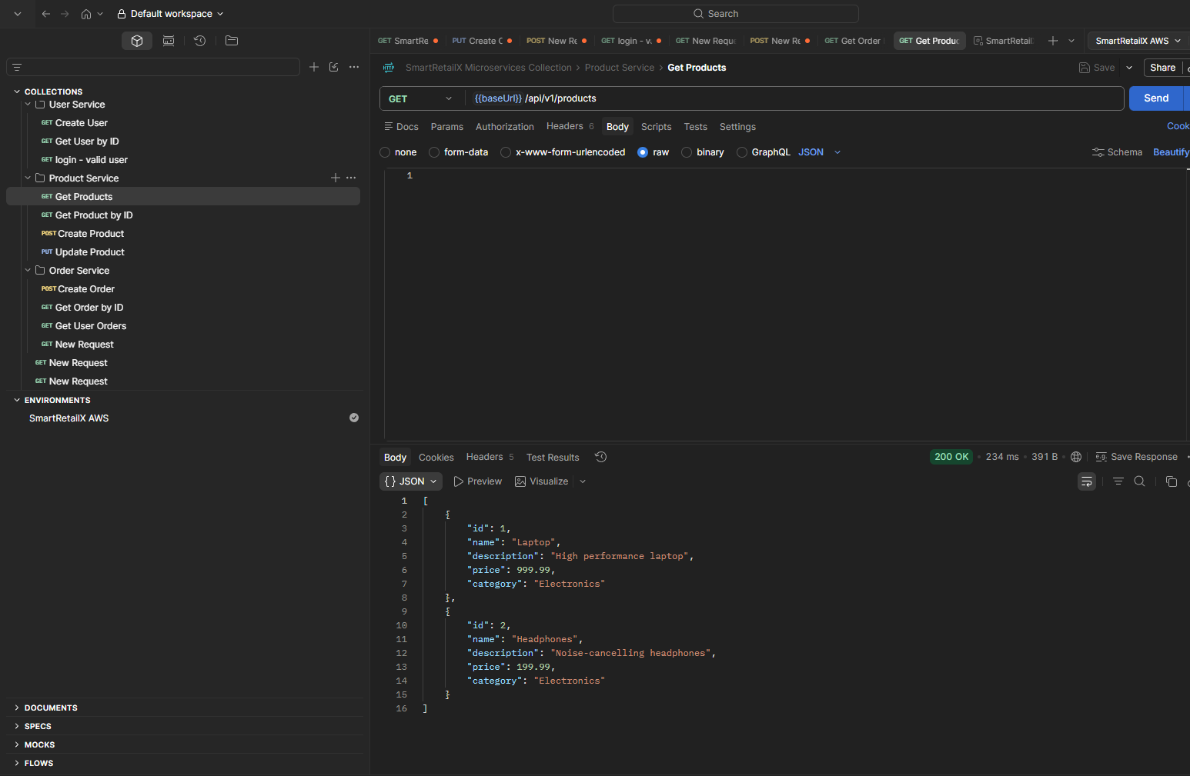
swagger 6

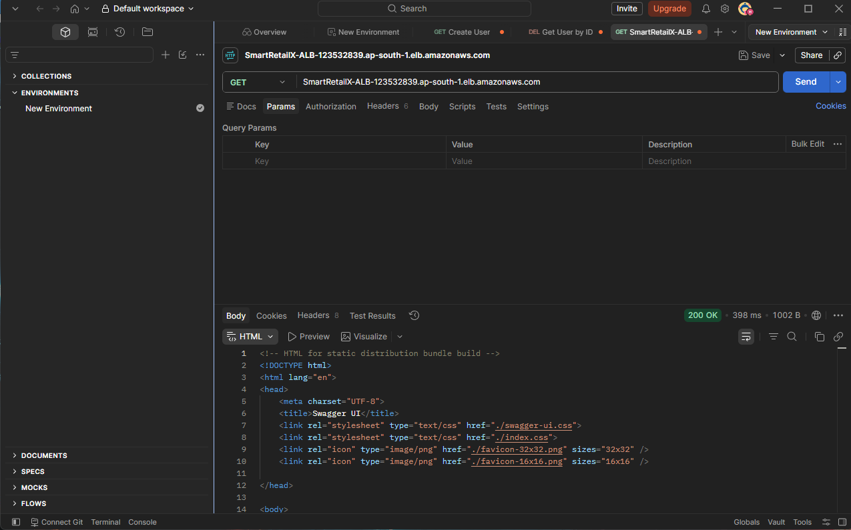
swagger 7

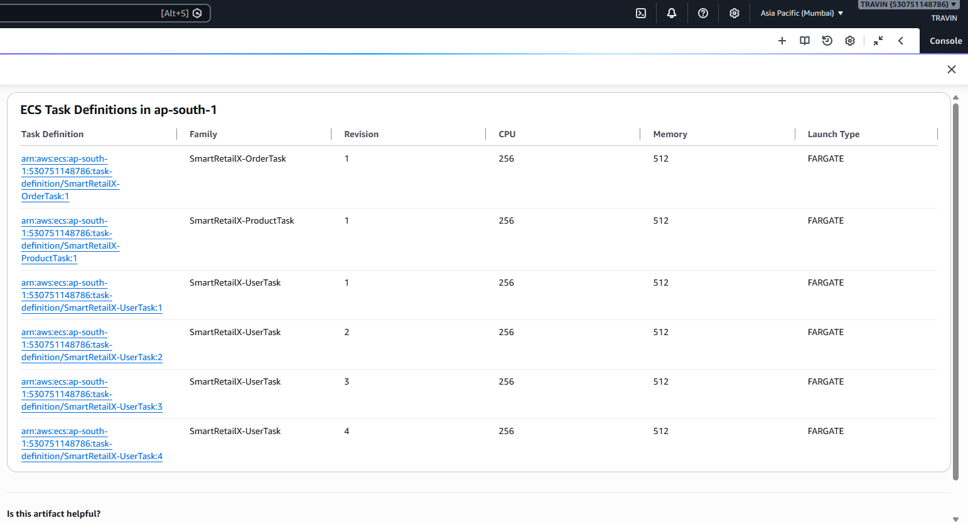
aws tasks 1
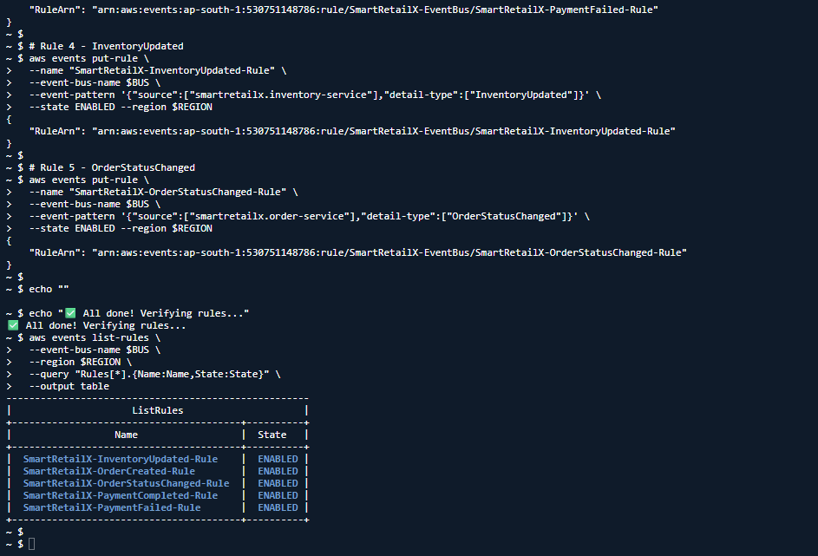
aws eventbd 1
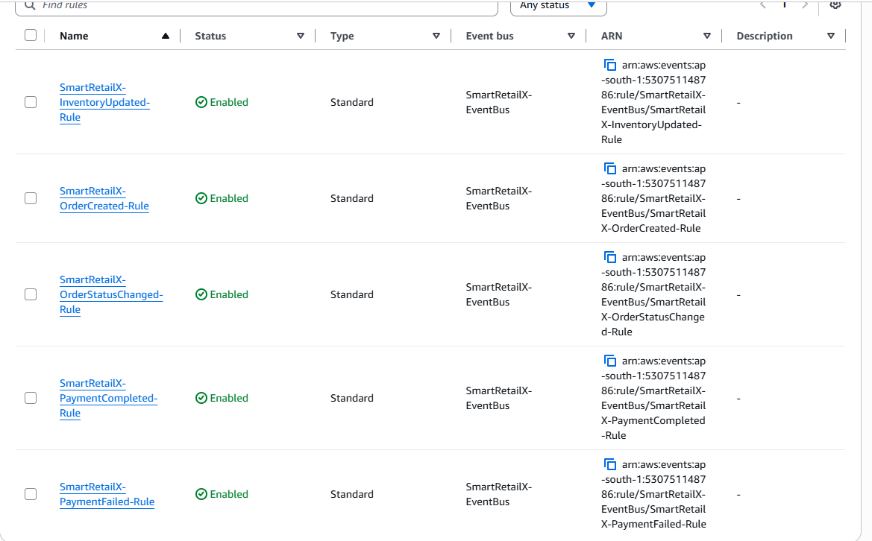
aws eventbd 2
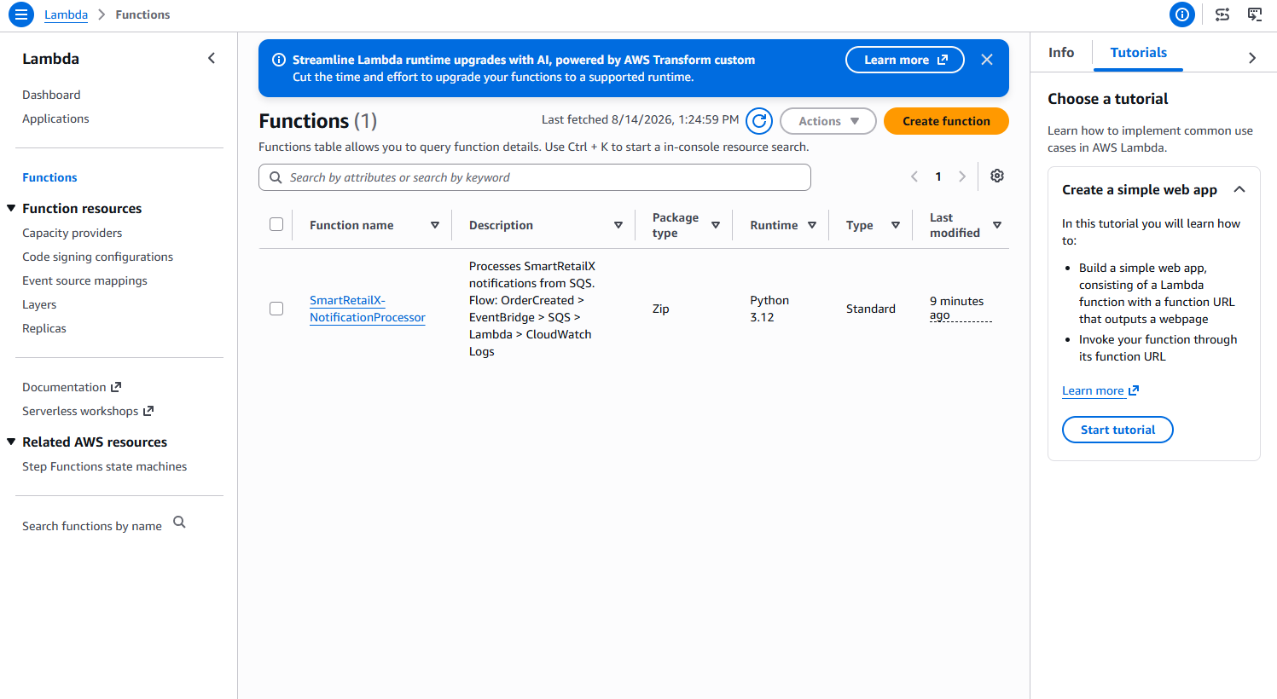
lambda 1
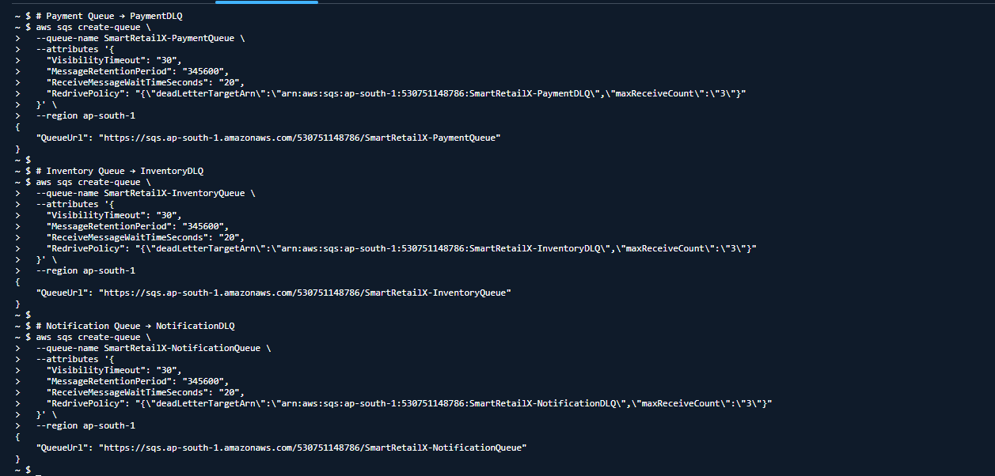
aws sqs 1
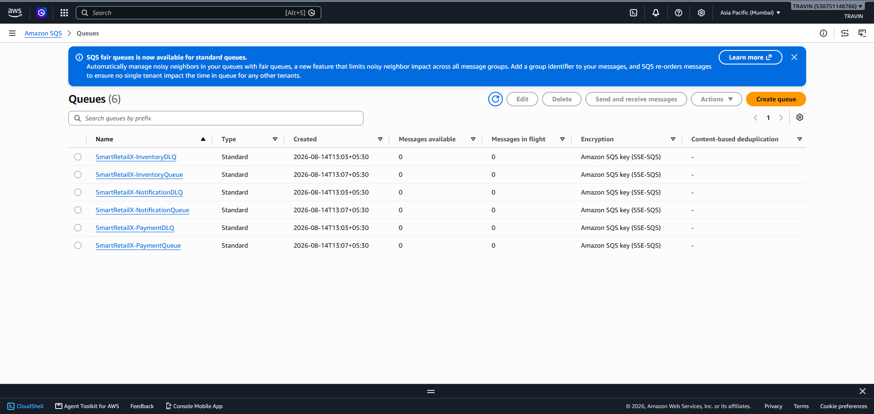
aws sqs 2
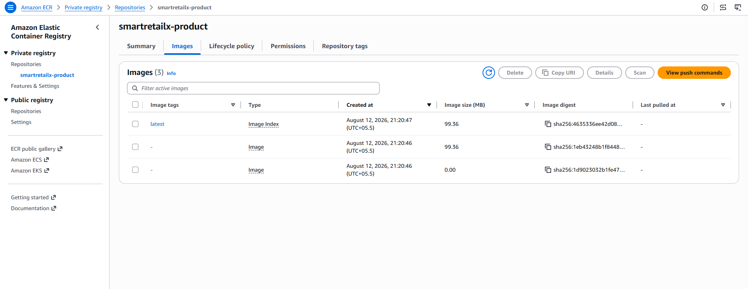
ECR 2
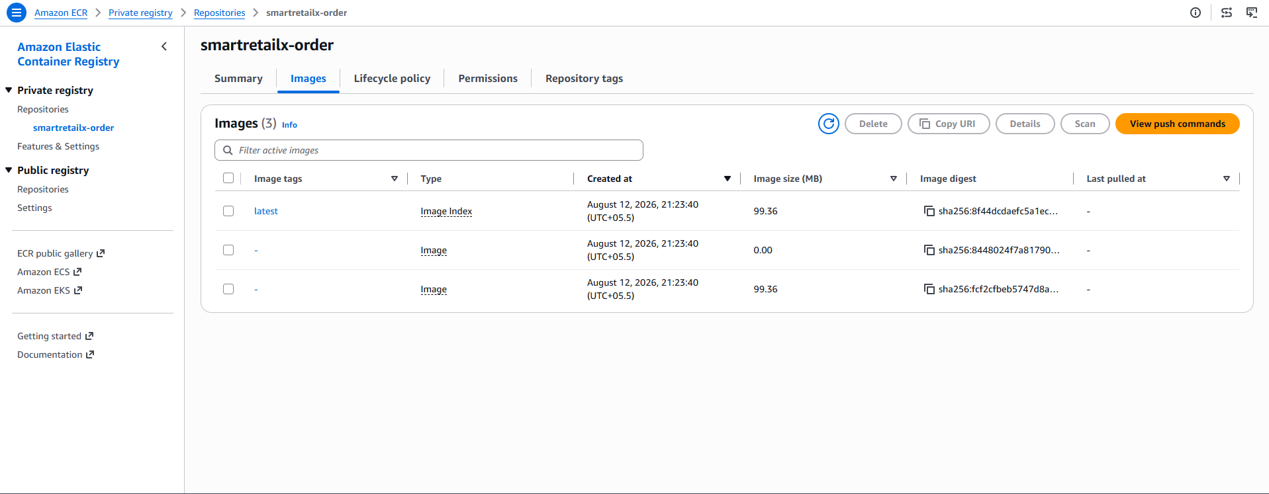
ECR 3
ECR 4

